Reducing GHG Emissions Through Aerodynamics on North American Railroads
Wayne A. Kennedy, Kennedy Consulting, USA
Bhargav Sowmianarayanan, Dassault Systemes, USA
Gregory Wright, Wabtec, USA
Abstract
Researching and implementing aerodynamic improvements on freight rail cars and locomotives holds significant promise for reducing GHG emissions and operational costs. Simple, lightweight, and inexpensive in-field modifications are possible to most major rail car types such as covered hoppers, autoracks and boxcars. Aerodynamic modifications to the locomotive shape is also discussed and the range of drag reduction and associated fuel savings reviewed. Various tools are available to measure and calculate drag reduction such as Computational Fluid Dynamics (CFD), wind tunnel and full-scale prototype testing both in controlled environments and freight revenue service.
Class I railroads in North America have partnered with the Science Based Targets initiative (SBTi) for the last five years, committing to very aggressive GHG emission goals by 2030 to 2034. Three of the six Class I’s have committed to a net-zero target emissions profile by the year 2050. Historically, the rail industry has improved fuel efficiency by an average of 0.9% per year going back two decades. If they continue that glide slope to 2030, they will collectively have a 20% gap between where their current improvement trend will take them and where they will need to be in order to meet their SBTi goals. New approaches will be required in the immediate future to help close that gap.
Aerodynamics is one possible solution that the trucking industry has used for decades with the help of DOE funding through different SuperTruck programs. Cumulative fuel economy improvements of 25% or more have been achieved compared to model year 2009 Class 8 tractors and trailers through aerodynamics alone.^{[1,2,3,4]}
There are over one million freight cars in service in North America with 40K to 50K new rail cars being built each year. Introducing simple modifications to the new builds as well as targeting the newer car fleets with in-field modifications can jump start the transition to more aerodynamic rolling stock. While the trucking industry benefited from over $323 million dollars in DOE funding through the various SuperTruck programs, the rail industry needs to make the investment to move aerodynamic research and implementation forward.
OEMs must drive a proactive approach to introducing aerodynamic concepts into future builds and some of them have already done so in the recent past or have plans to do so in the near future. Customer car owners and leasing entities will also have a role to play as many commercial issues will need to be addressed such as who pays for modifications versus who benefits in terms of fuel savings as well as car interchange issues with multiple railroads sharing associated fuel savings.
The benefit of aerodynamic improvements will last long into the future given that they are fuel agnostic. No matter what fuel source or combination of sources power locomotives far into the future, aerodynamic enhancements will ensure that less energy is consumed as the industry reaches towards a net zero carbon footprint target by 2050. Even under the scenario of zero emissions battery electric locomotives aerodynamic improvements would still help by increasing range and potentially speed.

Historical Fuel Savings Industry Performance
The rail industry commonly uses a fuel efficiency measure of Gallons per Thousand Gross-ton-Miles which has been tracked for many decades. Figure 1 shows each of the seven Class 1 railroads going back to 2001 with KCS only disclosing their fuel efficiency metric starting in 2011. Notice the Canadian railroads have generally been the best performers and starting in 2013 both distanced themselves from their US peers. Most railroads stay in their own fuel efficiency “lane” except for CSX that now looks more like a Canadian railroad in terms of exceptional fuel efficiency. Still, there remains a 31% gap between the best and most challenged railroads looking at the most recent year of 2022.
Figure 2 shows the weighted average performance of the Class I railroads, so it is an industry performance metric that indicates a 0.9% annual improvement going back to 2011. There are some anomalies such as 2018 and 2022 underperforming and 2020 overperforming. If we look at the aggregate SBTi goals out to 2030 and the glide slope required for the industry to achieve that goal, it will require from 2022 forward, a 3.1% year over year improvement in fuel efficiency to meet the SBTi targets. Whereas on the current historical glide slope, that would create a 20% percent gap between where railroads need to be and where they likely will be on their current trajectory or historical glide slope. Per the more challenging 1.5 degree Celsius SBTi goals to be announced by 2025 mentioned earlier, this will likely mean the slope of the line shown in Figure 4 will become even steeper.
Reference LMOA paper^{[5]} for the railroad specific SBTi goals and their various approaches to attain those GHG emissions reduction goals.
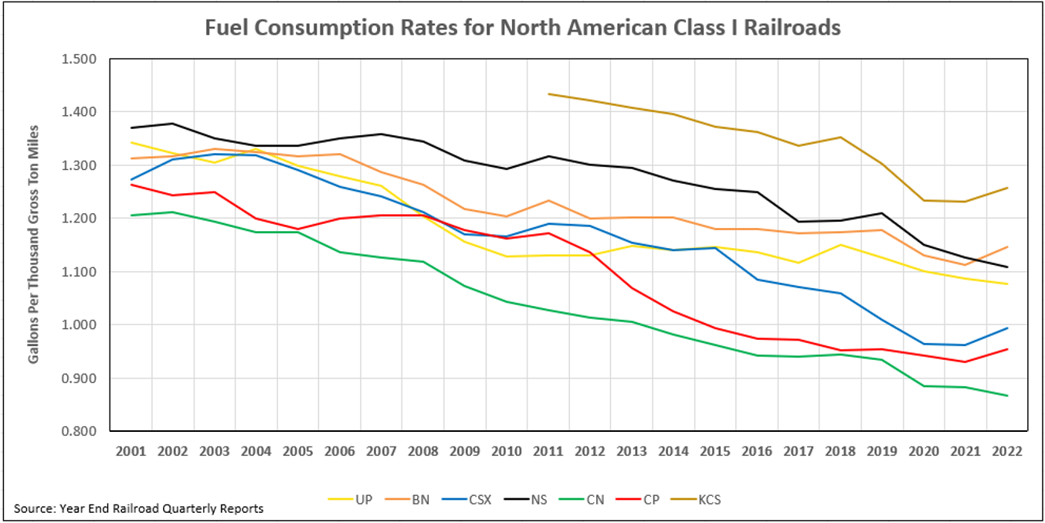Figure 1 – Fuel Efficiency for Class 1 Railroads
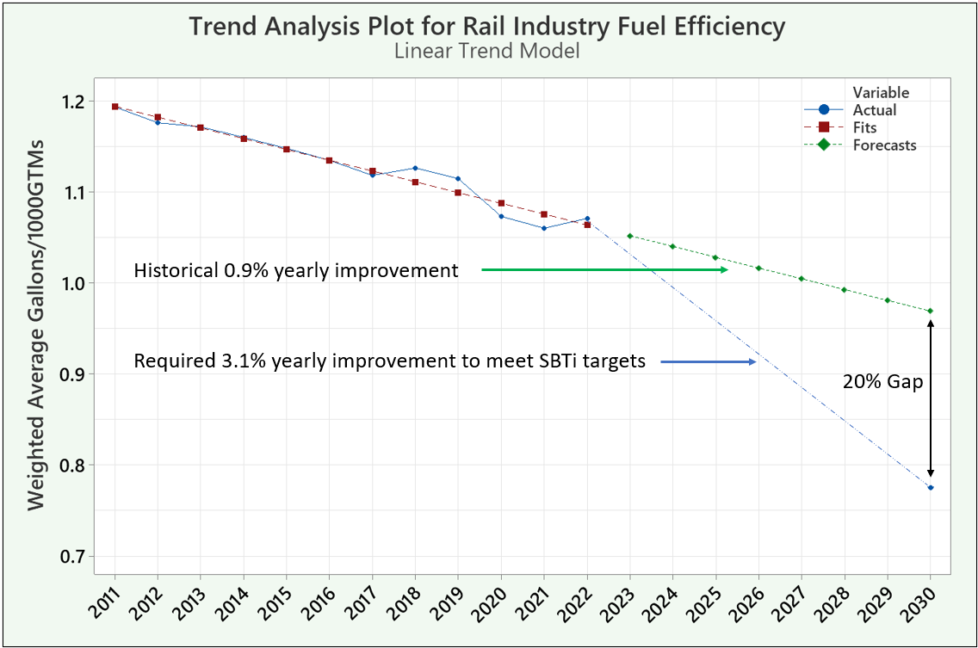 Figure 2 – Historical Glide Slope versus SBTi 2030 Goal

The Power of Aerodynamic Improvements
The shape of rail cars and locomotives within the North American freight industry have not changed in many decades and it is evident that little, if any consideration was made for aerodynamic efficiencies in the current and past designs being offered by the major OEMS for cars and locomotives.
A major western Class I railroad has historically performed a considerable amount of research on aerodynamic improvements to both locomotives and freight rolling stock. Many test methods were used including wind tunnel testing, Computational Fluid Dynamics (CFD) research, and full scale testing, both at TTCI in Pueblo, Colorado and in revenue freight service.
Figure 3 shows the curve of aerodynamic and other forces and the resistance required for each, to move trains at various speeds. Given all railroads are focused on increasing network speed and providing stellar service to their customer base, rail aerodynamics should play a future role in helping conserve fuel as network velocity increases.
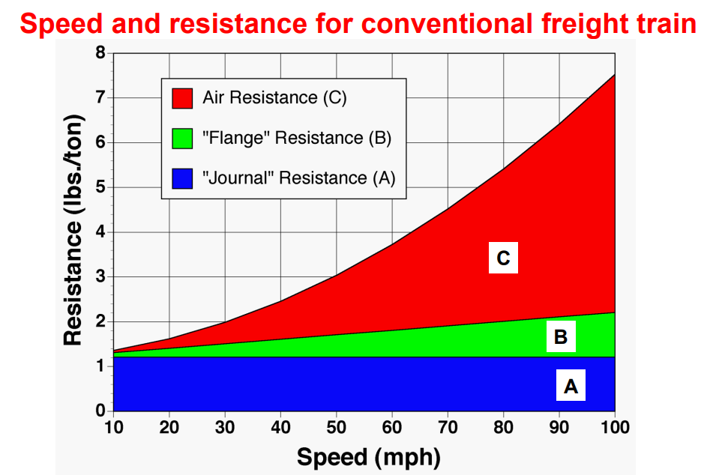Figure 3 – Resistance Forces for Freight Trains at Various Speeds^{[6]}

There is a precedent for aerodynamics within the rail industry beginning in the late steam locomotive era during the 1930’s. Streamlining steam locomotives was an attempt to conserve energy in the form of coal fuel for high speed passenger service.^{[7]} While the aerodynamic improvements were only substantial at higher speeds, it also served as a marketing tool to attract more passengers to travel by rail as the automobile was quickly gaining favor as the preferred mode of personal transport during that time frame. Figure 4 shows a J-3a Hudson on the Twentieth Century Limited operating between New York and Chicago.
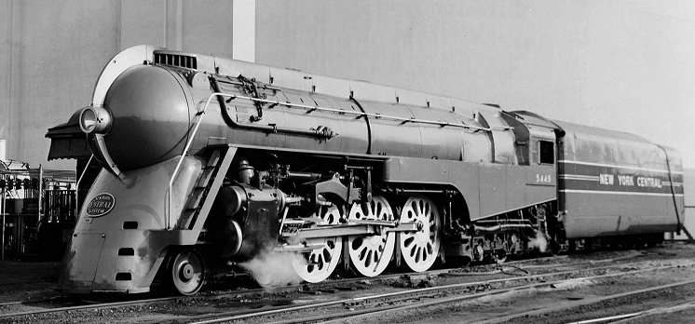
Figure 4 – J-3a Hudson, from Richard Leonard’s New York Central Collection^{[8]}

General Motors Electro-Motive Division (EMD) designed the diesel electric F-unit (designation for fourteen hundred horsepower) which was produced between 1939 and 1960 as a freight locomotive with longer EMD E-units designed for passenger service equipped with twin 900-horsepower diesel engines. These F-units were very successful “first generation” road or main line diesel locomotives and were largely responsible for replacing steam locomotives in freight service.^{[9]} Figure 5 shows a typical F-unit locomotive with an aerodynamic front nose design.
Unfortunately, the diesel electric locomotive designs from that point forward were built with little regard to aerodynamics, rather a boxy rectangular design that was the least expensive to manufacture at the expense of energy saving aerodynamic treatments. Freight car designs have also neglected simple aerodynamic principles which if instituted, could save 10% or more in diesel fuel savings and associated GHG emissions reduction.
The sections that follow will outline the simple modifications possible, to both new builds and existing car and locomotive fleets, that could reverse the neglect of aerodynamics. The beauty of aerodynamic improvements is that they are agnostic to fuel source, so they will save diesel fuel today and into the near future and whatever power source(s) are settled on into the distant future as the rail industry moves away from fossil fuels.
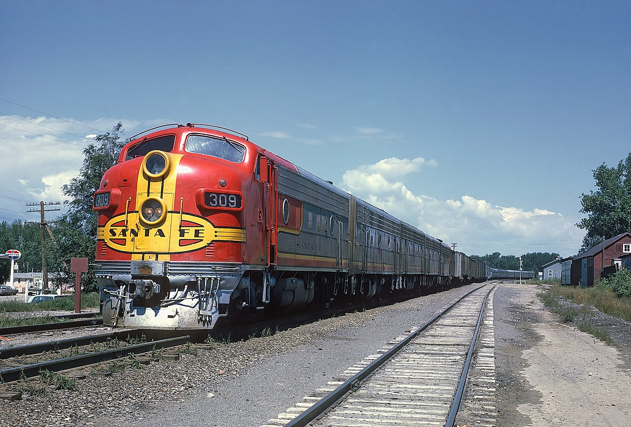
Figure 5 ATSF 309L with Train #23 The Grand Canyon in siding at Springer, NM, August 19, 1967, A. Roger Puta^{[10}}

DOE SuperTruck Program
The SuperTruck program was started by the Department of Energy’s Office of Energy Efficiency and Renewable Energy (EERE) in 2010 as a means of encouraging Class 8 tractor-trailer OEMs for the development of new vehicle technologies aimed at increasing freight efficiency. The program is now in Phase 3 and has awarded $323 million to various OEMs over the last 12 years.^{[11,12,13]}
Phase 1 of the program (2010 to 2015) required the four participating Class 8 OEMs to each produce a technology demonstrator vehicle whose freight efficiency (ton-miles per gallon) was at least 50% higher than their best in class 2009 on-road truck. Phase 2 (2016-2021) increased the goal to a 100% freight efficiency improvement over the 2009 baseline. Most teams achieved over 100% freight efficiency improvement within Phase 1 timelines and further improved vehicle efficiency in Phase 2 through developments in engine and overall vehicle technologies. As part of the program, OEMs also executed a phased adoption of these advanced technologies into their mainstream production vehicles, to ensure efficiency gains for the end consumer.
Aerodynamic improvements of the tractor-trailer system played a major role in achieving these efficiencies, with teams showing an average 25% fuel economy improvement through drag reduction.^{[1,2,3,4]} These improvements consisted of new designs for tractors as well as add-on aero treatments such as side skirts and front/rear fairings for the trailer.
The overall improvements in freight efficiency have yielded an estimated savings of over 300 million barrels of oil per year or roughly $30 billion per year in fuel savings for the trucking industry,^{[14]} with individual operators saving up to $20k per year. Phase 3 of the program (2022-2030) is now ongoing, focusing on greenhouse gas reduction through supporting the development of battery and fuel cell EVs along with charging infrastructure.

Virtual aero certification for Class 8 Trucks – EPA GHG Regulations
Tailpipe CO₂ emissions from Class 8 trucks are regulated by the EPA through its GHG Phase 1 and Phase 2 standards, issued in 2013 and 2021 respectively. As part of these regulations, Class 8 OEMs are required to provide numerous data points about a given vehicle configuration into an EPA simulation tool which is then used to calculate the vehicle’s CO₂ emissions. One of the key inputs in this process is the configuration’s aero drag coefficient. Due to the large number of component variants per truck model, each vehicle can have thousands of possible configurations, all of which must be certified in order to be sold and all of which must have their aero drag coefficient evaluated. Moreover, each aero drag evaluation must be carried out at two yaw angles (±4.5°) to produce a yaw-averaged drag coefficient that accounts for real-world wind conditions.
Given the large number of aero drag data points required for vehicle certification, the EPA allows for the use of CFD simulations to obtain this data and regulates the quality of these simulations through the relevant SAE standards. Specifically, SAE J2966 (Guidelines for Aerodynamic Assessment of Medium and Heavy Commercial Ground Vehicles Using Computational Fluid Dynamics) standardizes the requirements for CFD assessments from various technologies in order to be used in the virtual vehicle certification process. Additional CFD specifications are codified in 40 CFR § 1037.532 as part of the GHG Phase 2 rule. Leveraging CFD for virtual certification in place of scale model or full-scale testing has allowed OEMs to save millions of dollars and months of time, allowing them to complete their certification workload without any delays or adverse impacts to ongoing product development cycles.

CFD – History and Applications in Ground Transportation
Modern commercial Computational Fluids Dynamics (CFD) tools have been used among ground transportation industries including automotive, heavy truck and rail for aerodynamic applications since the 1980s. While CFD was initially used as a low-fidelity precursor to wind tunnel or full scale testing, improvements in modeling fidelity and the widespread availability of high performance computing have led to broader adoption of CFD for detailed engineering design and virtual certification.
Today, automotive OEMs leverage CFD as part of analysis-led vehicle development starting at the early concept stage with large-scale parallel Design of Experiment simulations. Such studies enable the OEM to identify regions of greatest aerodynamic benefit within a large design space and pursue further aero drag reduction through optimization at both the component and full-vehicle level. This is especially critical in the design of electric vehicles, which require maximizing operating range while meeting their unique safety and packaging criteria. As the design matures, virtual certification of vehicle configurations is carried out with CFD, adhering to processes and best practices that are approved by regulatory bodies both in the US and globally.
The heavy truck and bus industries also employ CFD widely for aero drag reduction, with OEMs pushed by fleet owners to develop and refine vehicle designs that minimize fuel consumption. In addition to its use as a design and certification tool, commercial vehicle OEMs utilize CFD to analyze scenarios unique to their vehicles including the impact of crosswinds on vehicle stability and tip over and the aero impact of vehicle platooning (drafting).
CFD use in the rail industry has historically focused on high-speed passenger rail, with the need to minimize aero drag and improve vehicle stability. However, with rising rail freight volume and fuel costs, freight rail OEMs and operators have increasingly turned to CFD to improve locomotive and railcar aero drag for fuel savings, while also addressing wind-induced tip over and other safety concerns. These include analyses of the train in isolation and also in relation to its surroundings, including elevated terrain and tunnels.
Outside of aero drag analysis, CFD tools are widely applied across the ground transportation industry to address various design problems in thermal management, cabin airflow, human comfort and aeroacoustic noise suppression.

The Freight Railcar Equipment Universe
There are well over 1 million freight rail cars in service in North America – which cars to begin modifying first and why is not a trivial question. Figure 6 shows the various types of freight cars.
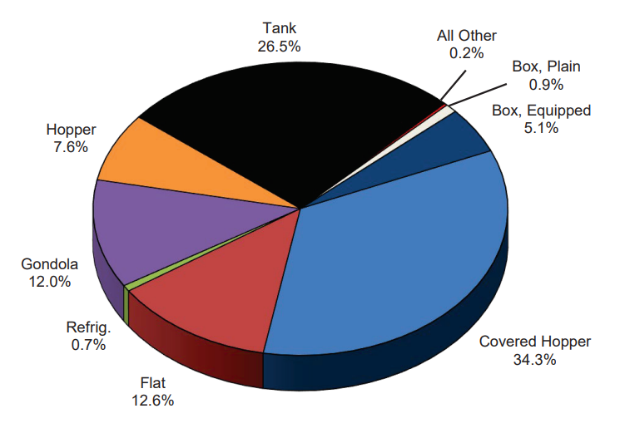
Figure 6 – North American Freight Cars by Type^{[15]}
Simple and lightweight in-field modifications have already been identified for covered hoppers, boxcars, autoracks (a portion of the Flat designation in Figure 6) and intermodal equipment. This represents over half of the different car types currently in service. As to the other half, tank cars are by their shape already the most aerodynamic type of car^{[16]} and the other car types, primarily gondolas and hoppers have opportunities that can also be investigated. Figure 7 shows train drag area by major railcar type where each train consists of 3 locomotives and 90 railcars.
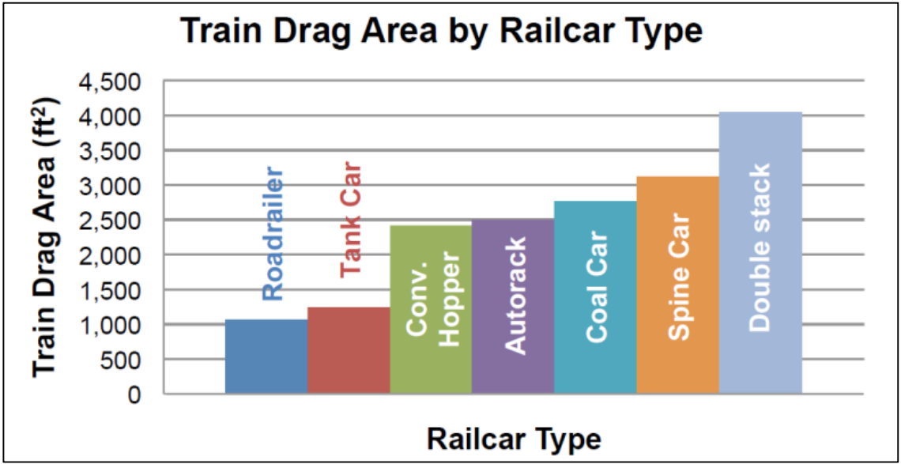
Figure 7 – Train Drag Area by Major Railcar Type^{[16]}

Prioritization should fall along various guidelines for in-service cars while new build cars will benefit from simple shape modifications installed during the build process for perhaps 1% to 2% extra cost. Figure 8 shows a matrix divided into three categories of owned cars, leased cars and new builds. For owned cars, those with high utilization such as covered hoppers and autoracks should be given priority. For leased cars, those which are the newest and commercially viable should likewise have the highest priority for in-field modifications. New builds are among the easiest to change as there is no need to take them out of service, and given the simplicity of the modifications, the time to manufacture should remain unchanged. Also, given there are anywhere from forty to fifty thousand new builds being introduced into service any given year, this helps to quickly introduce more aerodynamic car designs reducing fuel consumption and emissions quickly.
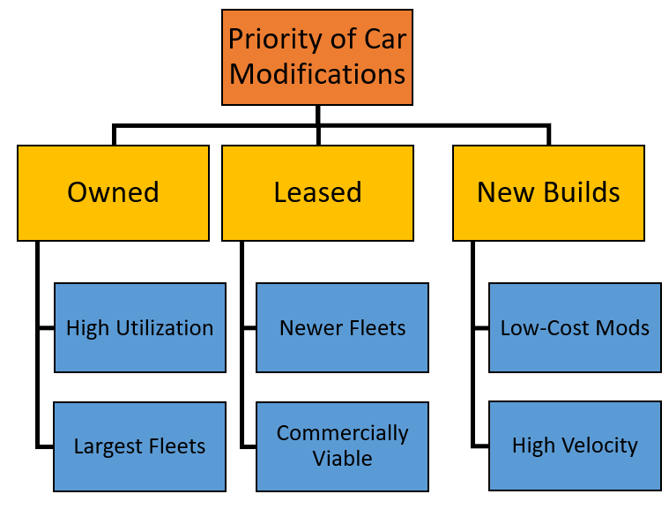
Figure 8 – Prioritization Matrix

Covered Hopper Aerodynamic Modifications
An example of simple modifications made to covered hoppers is shown in Figure 9 where both the cavities around the bottom hopper chute (highlighted in red) and top walkway supports have been enclosed providing a more aerodynamic and smooth side contour, removing sharp angles and open voids which create air turbulence and resulting excessive drag.
These lightweight modifications or aerodynamic treatments were simple to design and install and did not interfere with any visual inspection requirements.
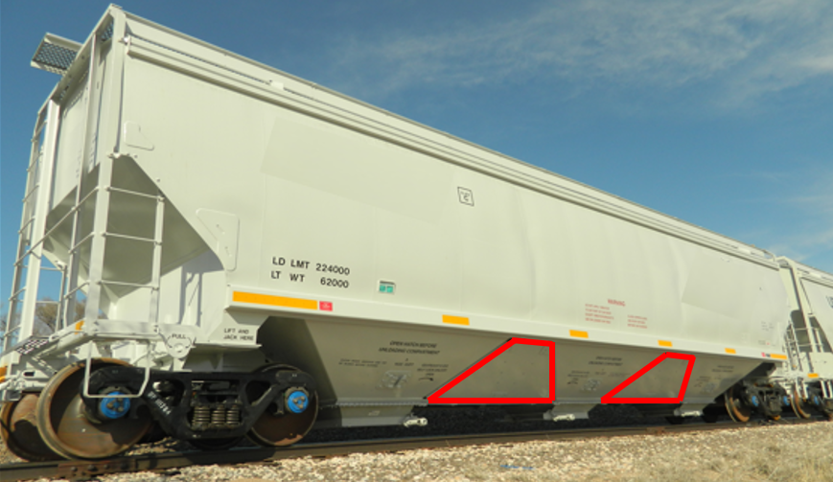
Figure 9 – Covered Hopper with Aerodynamic Modifications Installed (Red Outline Highlighted)

Surface pressure plots shown in Figure 10 indicate far less air impingement due to closing off the gaps between the dump gates. All these seemingly small modifications can add up to a big improvement in fuel efficiency.
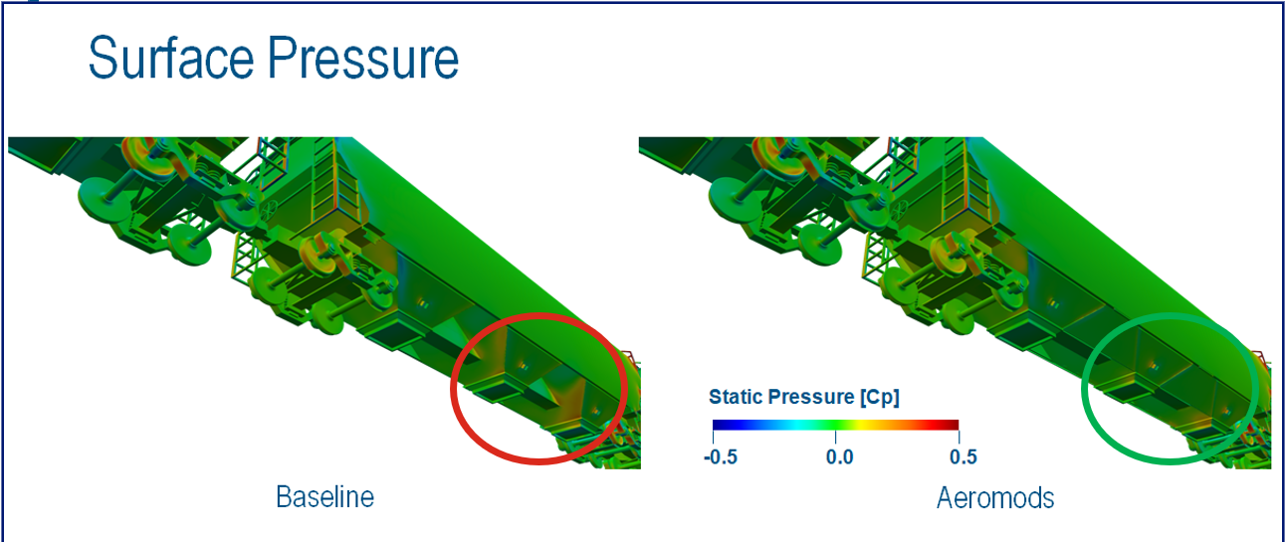Figure 10 – Surface Pressure Plot Showing Underbody Impingement with/without Aerodynamic Treatment^{[17}}

Revenue field testing was conducted on a unit train of 112 covered hoppers with aerodynamic modifications and a 7% reduction in fuel consumption was measured against similar non-modified unit trains operating over the same territory.

Refrigerated Boxcar Aerodynamic Modifications
Typical boxcar (including refrigerated) designs have a stamped roof structure for rigidity, though having a smooth surface on the exterior and a stamped pattern on the interior would provide a significant drag reduction while maintaining rigidity. Figure 11 shows a CAD model with CFD results showing how the corrugated roof on the outside (right hand side picture) needlessly creates stagnation points and excessive drag denoted by the slower air velocity. In this instance, switching the smooth roof to the exterior (left hand side picture) did not impact the cost for new builds of refrigerated boxcars.
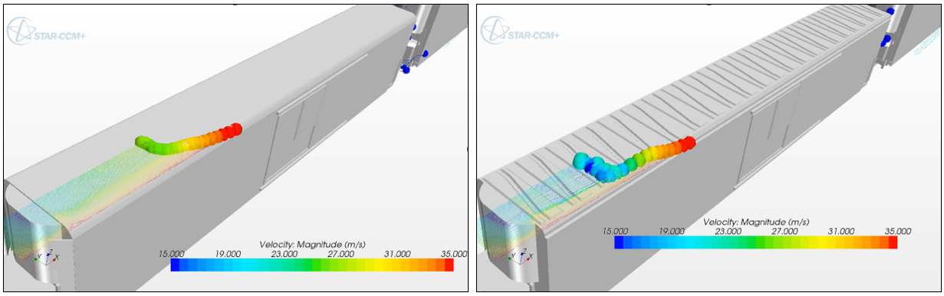
Figure 11 – Surface Velocity Plot Showing Air being Tripped on the Corrugated Roof Exterior^{[18]}

Further, the addition of low profile side skirts between the wheel bogies similarly reduced drag along the bottom of the car as shown in Figure 12. The side skirts and an underbody wheel bogie fairing significantly reduce the drag caused by the impingement of air on the bogie and underbody as can be seen in the higher air velocity (right hand side picture) compared to the conventional car design (left hand side picture) currently in operation.

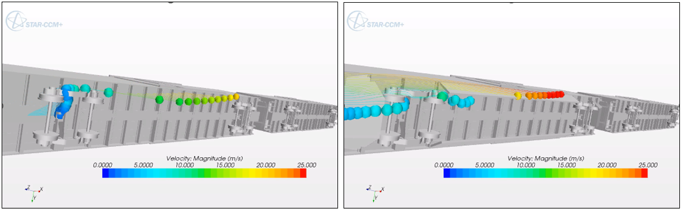
Figure 12 – Surface Velocity Plot Showing Air being Tripped Along the Car Underbody and Wheel Bogies

Another way to reduce drag for many different car types is to change the drawbar coupler design to decrease the car-to-car end wall distance. When this was applied to a new build of refrigerated boxcars, the distance decreased by 14 inches which resulted in less airflow impingement between the cars all along the length of a unit train where all cars have been appropriately modified. This change would likely not incur any extra cost on new builds.
CFD results for all three modifications indicated a drag reduction of almost 30% which translates into a fuel savings of 9% at revenue service speeds.

Autorack / Multi-level Aerodynamic Modifications
Autoracks are another prime candidate for aerodynamic improvements. There are multiple areas of opportunity in terms of drag reduction, namely a smooth roof from the existing corrugated design, a change to the punch hole pattern on the side wall screens and enclosing the underbody chassis voids which act to trip air passing underneath the car. Figure 13 shows the existing car design with the modified side sheet punch hole pattern installed.
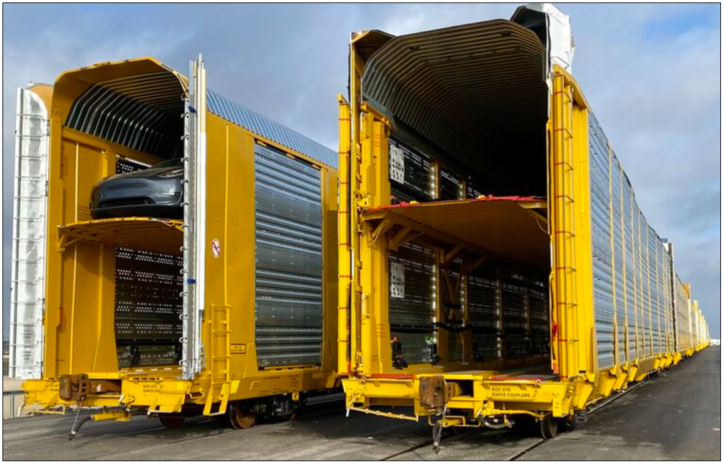
Figure 13 – Autorack Vehicles with Doors Open and Aeroscreens Installed on Sidewalls

Extensive wind tunnel testing was performed to determine the extent of drag reduction for each of the three modifications. Figure 14 shows iterations for the smooth roof design, showcasing the coefficient of drag (C_{d}) as a function of Reynolds number (R_{e}). A drag reduction of 14% was measured which for a unit train of Autorack cars would equate to approximately 5% in resulting fuel savings.
Full scale testing was conducted on a dozen new car builds with both the smooth roof and modified punch hole pattern for the side walls. An energy reduction of 5% was measured at a track velocity of 40 MPH and over 10% for 60 MPH.
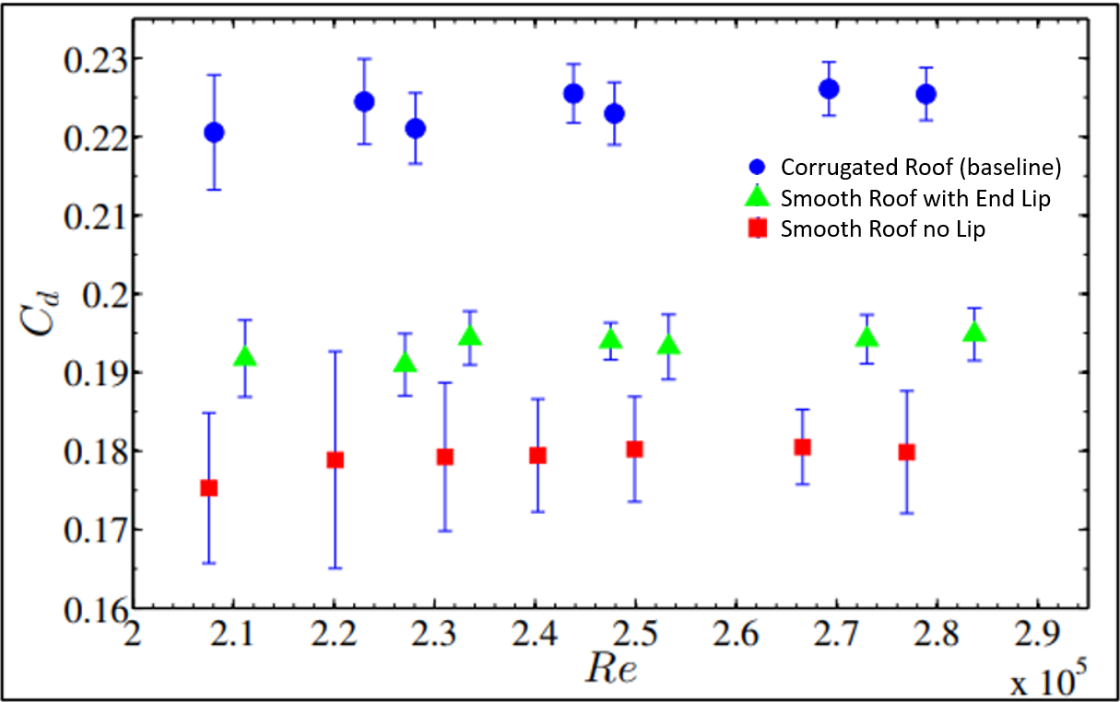
Figure 14 – Smooth Roof Iterations Showing C_{d} as a Function of R_{e} ^{[19]}

Interomodal Well Car / Container Aerodynamics
Rail transport of containers is three to four times more fuel efficient than truck transportation and a growing business thanks to cost advantages. Unfortunately, intermodal trains tend to have high aerodynamic drag given the wide variability of equipment matching (container size to car well size) and equipment loading (single or empty slots) variability.
An extensive study^{[20]} was performed looking at the impact of equipment slot utilization on aerodynamic drag. Figure 15 shows various configurations for both 48 and 40 foot wells and their corresponding drag coefficients (C_{d}). A large variation in drag can be seen depending on loading density (minimal single or empty stacks) within a train. The drag differential for a well-built Intermodal train with few gaps or single stacks can be almost half compared to a poorly built train with many empty and single stacks throughout the length of the train.
Most if not all of these aspects of intermodal train make-up can be managed, controlled and optimized during load planning. This could result in substantial fuel savings.
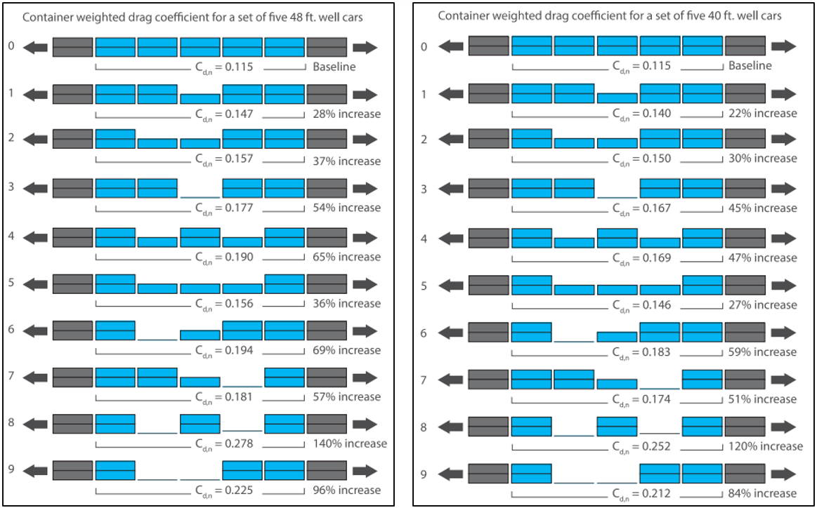
Figure 15 – Cd Variation Depending on Train Loading Density^{[20]}

Further, the gap between containers even when fully double stacked can also cause large variations in train drag. When 40 foot containers are placed in larger wells built for 53’ boxes there will be an increase in the size of the inter-car gap and aerodynamic drag. On the other extreme “overhang” placement where the top container is longer than the bottom container will result in lower aerodynamic drag. Figure 16 shows the amount of variability possible with differing gap size depending on how the train is made up.
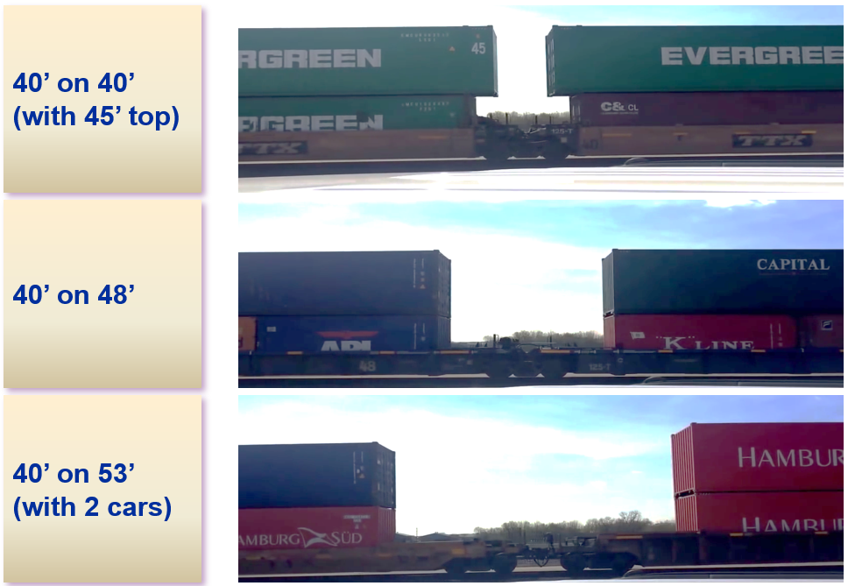
Figure 16 – Variance of Gap Size Between Top Container Wells

Wind tunnel testing on a variety of container to container gaps revealed the curvilinear relationship shown in Figure 17 between the gap size (L_{g}) and the coefficient of drag (C_{d}). Drag virtually doubles between the extremes of a very narrow gap (53 foot containers overhanging on 40 foot wells) and a very large gap (40 foot containers on 53 foot well cars)
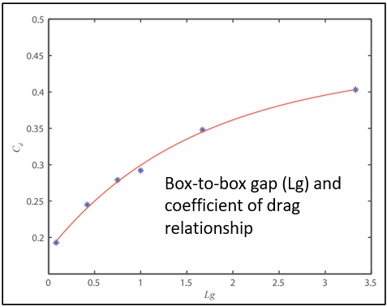
Figure 17 – Relationship Between Top Container Gap and Coefficient of Drag^{[20]}

A summary of operational improvements that can be made are to reduce the top container to container gap, place longer containers on the top position (if able to mix domestic 53 foot with international 40 foot) and group single stacks and spine cars to the rear of the train. Depending on the level of improvement possible against the existing base case, fuel savings approaching 10% can be achieved.

Intermodal Well Car / Container Aerodynamic Improvement
Train make up is where most of the aerodynamic improvements can be made, though there are still opportunities to modify existing equipment for smaller drag reduction and associated fuel savings.
A patented micro-fairing or low profile deflector concept for intermodal containers and freight cars called the RoofRider has been developed using both CFD and wind tunnel testing. Figure 18 shows CFD results indicated less air impingement with the fairing attached to the top ends of the intermodal container. A drag reduction of approximately 5% has been measured which would equal 1.5% fuel savings for a simple, lightweight, and inexpensive addition to container fleets.
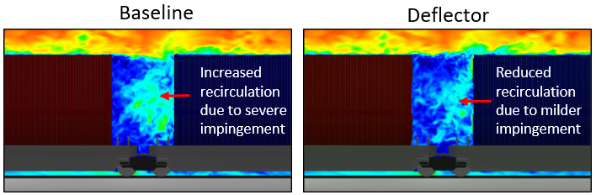
Figure 18 – Technology Deflects Air Over the Inter-car Gap, Reduces the Force on the Following Container^{[21]}

The shape and size of the deflector is shown in Figure 19 and depicted in wind tunnel testing on 1/29th scale intermodal equipment.
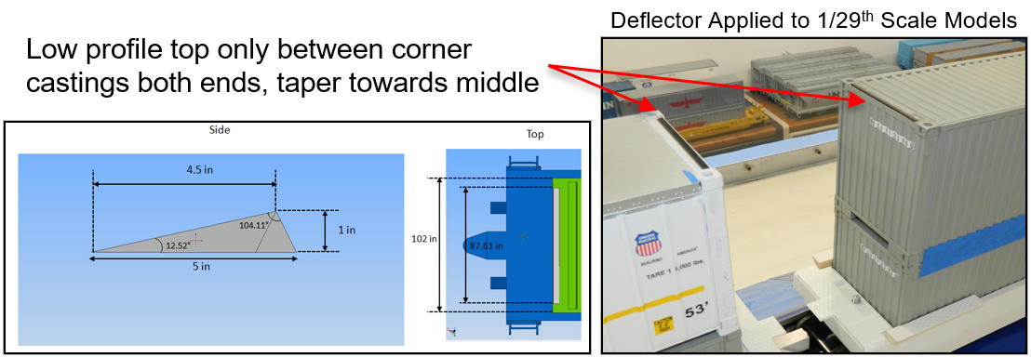
Figure 19 – Size and Shape of Intermodal Container Deflector

Locomotive Aerodynamic Modifications
While aerodynamic improvements to the locomotive can yield a significant reduction in drag for the locomotive itself, the associated fuel savings for the entire train will be relatively small given there is only one front of a train. Still, a 1% to 2% fuel savings for the entire train is possible depending on the degree of modifications introduced and the length and speed of the train.
Numerous studies have been conducted ranging from small shape modifications to an entire locomotive body redesign complete with covered walkways and a passenger locomotive style aerodynamic nose. Figure 20 shows a detailed CAD model of a modern Wabtec Evo locomotive, created and analyzed for CFD analysis by Dassault Systemes.
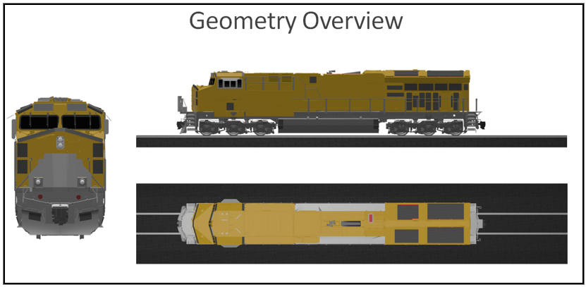
Figure 20 – Detailed CAD Evo Locomotive Model used for CFD Analysis

Figure 21 shows aerodynamic transition concepts on the left hand side, helping to reduce the sharp edges and tripping points which create drag. The right hand side depicts a foldable origami inspired aerodynamic nose cone which reduces the blunt shape of the current locomotive nose face.
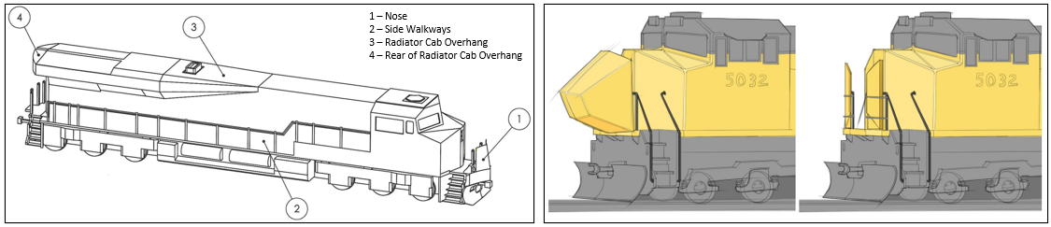
Figure 21 – Various Locomotive Transition and Nose Cone Concepts Tested with Wind Tunnel and CFD^{[22,23]}

Though the fuel savings from the associated drag reduction is smaller than that possible with freight car modifications, there are also far fewer locomotives to upgrade compared to the size of the freight car population within North America. Given aerodynamic improvements are agnostic to future fuel source, it’s likely that future locomotive shape design will migrate towards a more aerodynamic shape profile. Whether or not the installed base of tens of thousands of “lead capable” locomotives within the Class I freight universe will see future aerodynamic modifications remains to be seen.

Wind Tunnel History
The first wind tunnels were developed in the late 1800’s in France, Great Britain and Russia.^{[24]} In 1901, the Wright brothers created a wind tunnel to test different wing shapes that would eventually carry them into the air.^{[25]}
The first major wind tunnel in the United States was built at NASA’s Langley Research Center at Hampton Virginia in 1920.^{[26]} The largest wind tunnel in the world is at NASA’s Ames Research Center at Moffett field California which has the capability to test aircraft with wing spans of up to 100 feet. Figure 22 shows the drive fan configuration at the National Full-Scale Aerodynamic Complex.
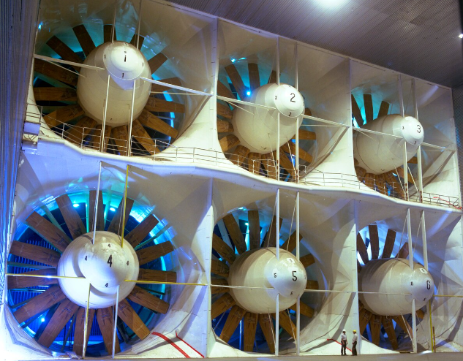
Figure 22 – Inlet Section of the Largest Wind Tunnel in the World at NASA Ames Research Center^{[27]}

A wind tunnel is often identified by the size of the test section, not the overall size of the wind tunnel itself. The test section is the area or chamber in which models or other objects are placed. The models are typically fitted with sensors that measure the push force against the model of the air drawn through the test section. A common type of wind tunnel is open circuit where air is drawn through the test section by a turbine, having passed first through an inlet screen and a contraction cone to increase the air velocity. After passing through the test section, the air then flows through a diffuser and exits through the turbine blades.
BYU designed and built an open circuit wind tunnel in the late 1950’s shown in Figure 23. The device was purchased in 2015 by a major Class I railroad and modified to perform dedicated aerodynamic research on G scale locomotive and freight car equipment. The wind tunnel is equipped with six moveable sensors along the length of the 25 foot plexiglass test section
The wind tunnel was donated and moved to TTCI in 2019 and is now stored at MxV Rail in Pueblo, Colorado waiting for funding (or a paying customer) to put it back into operation. It is likely one of the few medium-sized wind tunnels in North America, if not the only one that is configured for dedicated freight railcar operation and analysis.

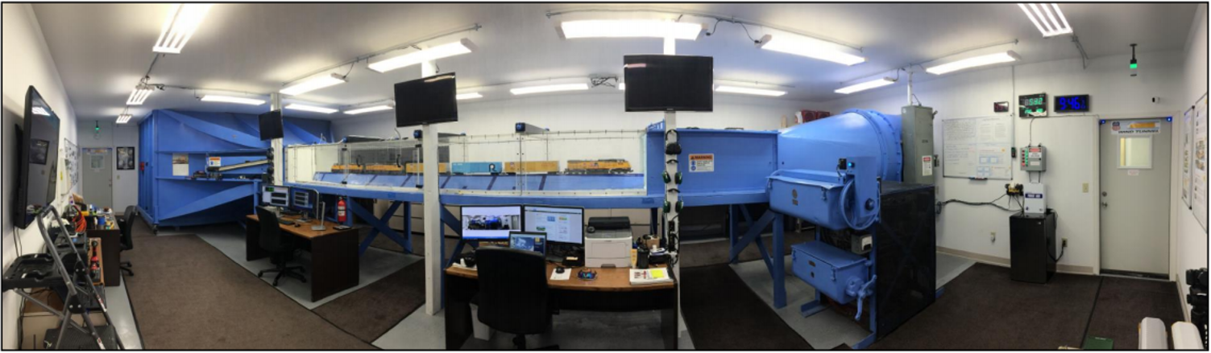Figure 23 – Wind Tunnel Configured for G scale (1/29th) Model Testing

OEM’s and Suppliers Beginning to Offer Aerodynamic Choices
There are freight railcar builders who have begun offering more aerodynamic versions of common car types. Some of these offerings are packaged with other improvements such as the Tsumani GateTM covered hopper shown in Figure 24, which is also designed to offer customized discharge speed control. Further, the industry is looking to move to automated roof hatch covers which would be a huge safety improvement as well as removing the roof walkways which are a large contributor to overall car drag.
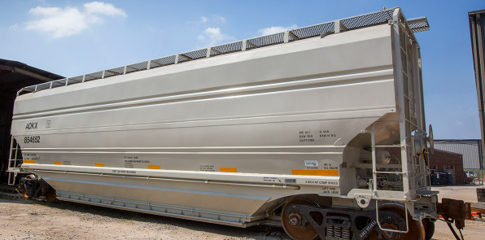
Figure 24 – Tsunami GateTM Car Offering^{[28]}

Other car offerings such as a smooth sided Transverse Ultra-Fast-Flow (TUFF) coal car and a tandem Autorack car are showcased in Figure 25. The aerodynamic drag reduction and associated fuel savings from these relatively new offerings are significant though have not yet been fully embraced by the industry who continue to choose the “lowest cost” version at the expense of long term fuel savings and emissions reduction.
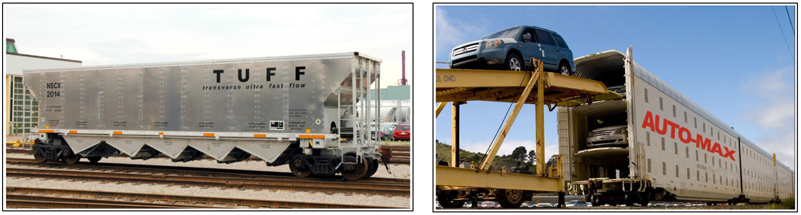
Figure 25 – Smooth Sided Coal Car and Tandem Smooth Sided Auto-Max Car^{[29,30]}

Suppliers to freight railcar builders are also beginning to offer more aerodynamic solutions. Figure 26 shows modified side screen panels. This same vendor is also designing a smooth roof to replace the corrugated roof and other aero treatments for covered hoppers.
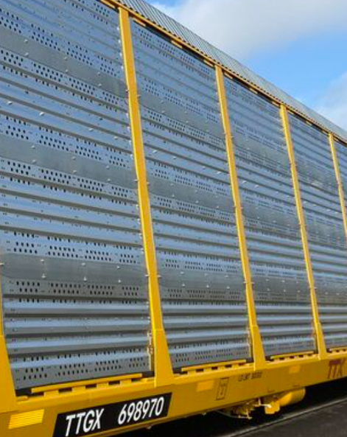
Figure 26 – Aeroscreens with a Modified Punch Hole Pattern^{[31]}

How to Approach Given Various Freight Car Owners
Railroads own anywhere from 15% to 40% of the freight cars that they haul with the other cars being either customer owned or leased car fleets. With such a variety of car ownership, the issue of who pays for aerodynamic treatments for operational fleets versus who benefits from the fuel savings will have to be addressed.
Figure 27 shows a possible path forward. There are three main entities that own railcars, the railroads themselves, customers who own fleets for convenience/optimization of operations and leasing entities such as TTX. Some of these fleets will traverse on various railroads as a normal way of doing the business of moving freight.
What is most important is that the path forward accelerates aero modified cars into service while prioritizing newer fleets that have high utilization/mileage. All entities will share in the ESG GHG emissions success spotlight, taking credit where credit is due. The commercial discussions regarding who pays versus who benefits should focus around either fuel surcharge mechanisms or existing rate structures. For leasing entities, aero modified cars will charge a higher lease rate given the lower operating cost in terms of fuel savings.
Leveraging new builds and unit trains are both methods to increase adoption and penetration of aero modified cars in general circulation. Further, where applicable, carbon credits can be generated and leveraged by entities that pursue more aerodynamic friendly options.
The trucking industry has been sharing aero enhanced trailers and trucks for decades. There is no valid reason why railroads can’t go down a similar path.
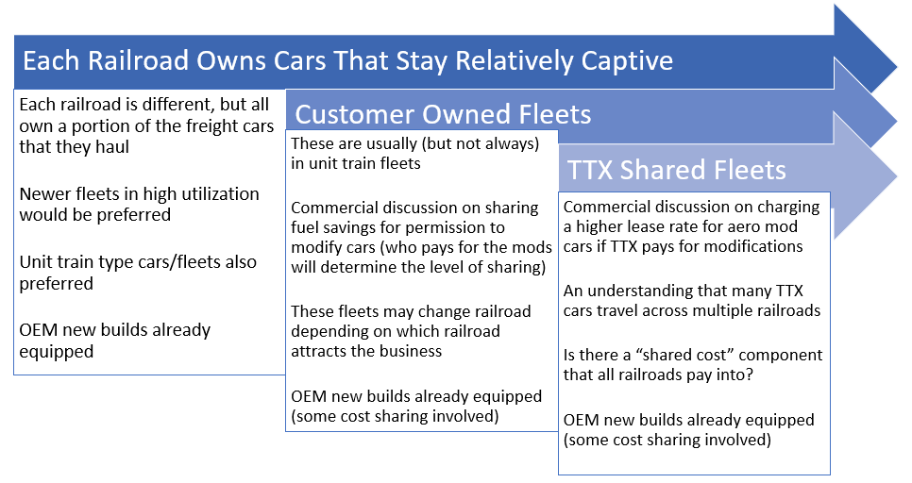
Figure 27 – How Railroads, OEMs and Lease Owners Can Move the Ball Forward

Conclusions
Aerodynamic treatments are available for most major freight car types and involve smoothing roof lines, applying side skirts and underbody treatments to smooth transition and trip points all with the intent of reducing drag and improving fuel conservation. These simple aerodynamic modifications can either be designed and included for new builds or installed in kit form for existing car fleets already in service that are going through periodic maintenance cycles.
There are challenges, as railroads only own a portion of the cars that they haul. Who pays for the modifications versus who sees the fuel savings, will all have to be worked through. At the very least, new builds with aerodynamic modifications should be the first tranche of aerodynamic cars introduced. Recently purchased fleets should then be the next priority with in-field modification kits made available. Customer owned fleets would also be a key opportunity as would leased fleets from TTX and other car owners.
Funding for continued research on aerodynamic opportunities will be key. Government funding through the FRA operated TTC or the AAR operated MxV Rail to perform not only wind tunnel testing, but also full scale energy tests will be a requirement. CFD analysis will also be required, and OEM assistance and support for both locomotives and rail cars will likely help drive needed improvement. A multi-year plan with industry leadership to drive progress and sharing of best practices to accelerate the pace of improvement will be necessary.
As the GHG emissions goals approved through SBTi continue to become more aggressive moving to the preferred 1.5 degree C standard, aerodynamic improvements will become a necessity if these goals are to be met by 2030 and beyond.
Given aerodynamic improvement technologies are agnostic to the fuel type being used to pull freight, they will be just as useful in the future for Battery Electric or Hydrogen Fuel cell powered locomotives pulling revenue freight trains. As railroads set their sights on a net-zero path by 2050, aerodynamics will play a role in helping them transition to whatever future fuel sources the industry chooses in the long term.

REFERENCES
- Volvo SuperTruck1 2016 Annual Merit Review presentation (slide 6) https://energy.gov/node/1857431
- Volvo SuperTruck2 2019 Annual Merit Review presentation (slide 9) https://energy.gov/node/4268192
- Peterbilt SuperTruck1 2014 Annual Merit Review presentation (slide 20) https://energy.gov/node/937106
- Peterbilt SuperTruck 2018 Annual Merit Review presentation (slide 23, 27) https://energy.gov/node/3538088
- Kennedy, W. “GHG Emissions Reduction for North American Railroads” LMOA – Proceedings of the 84th Annual Meeting, pp. 198-204 (October 2022)
- Train Energy, Power and Traffic Control J. Riley Edwards, University of Illinois at Urbana-Champaign
- https://www.steamlocomotive.com/types/streamlined/
- Richard Leonard's New York Central Collection -- J-3a 4-6-4 5449 (railarchive.net)
- https://en.wikipedia.org/wiki/EMD_F-unit
- https://en.wikipedia.org/wiki/EMD_F-unit#/media/File:ATST_309_(Flickr_22322834666).jpg
- Phase 1: https://www.ttnews.com/articles/doe-awards-1157-million-develop-supertruck
- Phase 2: https://www.energy.gov/artiles/doe-announces-80-million-funding-increase-supertruck-efficiency
- Phase 3: https://www.energy.gov/articles/doe-announces-162-million-decarbonize-cars-and-trucks
- https://www.energy.gov/articles/infographic-how-supertruck-making-heavy-duty-vehicles-more-efficient
- AAR Railroad Facts 2021 Edition PDF
- Aerodynamic Analysis of Intermodal Freight Trains Using Machine Vision, Kumar et all, University of Illinois at Urbana-Champaign
- BYU Capstone Engineering for C5 Grain Car Aero Improvements 2014-2015
- BYU Capstone Engineering for Refrigerated Boxcar Aero Modifications 2013-2014
- "Aerodynamic Improvements for Auto-Carrying Railcars" by Robert Arthur Condie (byu.edu)
- "Aerodynamic Drag On Intermodal Rail Cars" by Philip Donovan Kinghorn (byu.edu)
- Product | Rail Energy Efficiency | RoofRider
- Design of an Origami-Inspired Deployable Aerodynamic Locomotive Fairing (byu.edu)
- BYU Capstone Engineering Locomotive Aerodynamic Treatments 2011-2012
- A century of wind tunnels since Eiffel - ScienceDirect
- NASA - The Wright Brothers' Story
- NASA - NASA's Wind Tunnels fact sheet
- AEDC's National Full-Scale Aerodynamics Complex team celebrates 25th anniversary of the world's largest wind tunnels > Arnold Air Force Base > Article Display (af.mil)
- 5185 Tsunami Gate™ Covered Hopper - The Greenbrier Companies (gbrx.com)
- Auto-Max® II - The Greenbrier Companies (gbrx.com)
- Coal | National Steel Car
- Increase Fuel Savings Through Railcar Aerodynamics - Railway Age

