V7 June 22, 2022
GHG Emissions Reduction for North American Railroads

Wayne A. Kennedy, Kennedy Consulting, USA
Steven G. Fritz, Southwest Research Institute, USA
Christopher R. Stoos, Southwest Research Institute, USA

Abstract
This paper provides an overview of North American railroads fuel consumption trends, technologies and other initiatives implemented in recent years to improve fuel efficiency, and details the challenges set forth to meet the GHG reduction targets while simultaneously meeting ever-more stringent criterial emission limits (NOx and PM). Case studies of recent projects to improve the diesel engine fuel efficiency will be presented, along with a discussion of engine, locomotive, and train level fuel economy improvements that will likely need to be explored in the future. Finally, we will highlight low-carbon fuel options and carbon-free initiatives that the railroads have announced or are currently pursuing, such as battery electric and hydrogen fuel cell powered locomotives.
North American freight railroads are all non-government, publicly traded companies (with the exception of BNSF which is owned by Berkshire Hathaway), with seven large “Class 1” (annual revenue greater than $250 million) railroads that combined consume approximately 13.6 billion liters of diesel fuel each year. Each of these railroads have recently announced greenhouse gas (GHG) emissions reduction targets under the Science Based Targets initiative (SBTi) as a first step towards low-carbon freight transportation. These railroads have made consistent and steady improvement in fuel efficiency over the last decade, on the order of approximately 1% per year as an industry, but additional fuel efficiency gains will need to be even more aggressive to meet the SBTi goals of roughly 35% reduction of Scope 1 GHG emissions intensity by the year 2030.

SBTi Scope Emissions and Reduction Goals for the Industry
The Science Based Targets initiative (website sciencebasedtargets.org) was established in 2015 to help companies to set emission reduction targets in line with climate science and the Paris Agreement goals. The Paris Agreement’s long-term temperature goal is to keep the rise in mean global temperatures to well below 2 degrees Celsius above pre-industrial levels, and preferably limit the increase to 1.5 degrees Celsius.
Figure 1 shows the differing scopes and a brief description of each scope. Scope 1 covers direct emissions from owned or controlled sources, diesel fuel burned in locomotives in this case for rail. Scope 2 covers indirect emissions from the generation of purchased electricity, steam, heating and cooling consumed by the rail reporting company. Scope 3 includes all other indirect emissions that occur in a company's value chain which for railroads is significant regarding the production and transportation of diesel fuel, steel rail and track ties - three of the largest purchased commodity groups for railroads in general.
There are two main metrics used for GHG emission measures; an absolute metric which is directly tied to how much diesel fuel is burned and is referenced in metric tons of CO₂ equivalent, and the more common measure based on intensity using either gross ton miles or revenue ton miles, as a base measure producing an intensity rate which is volume neutral. Example units are gCO₂e/RTM (revenue ton mile).

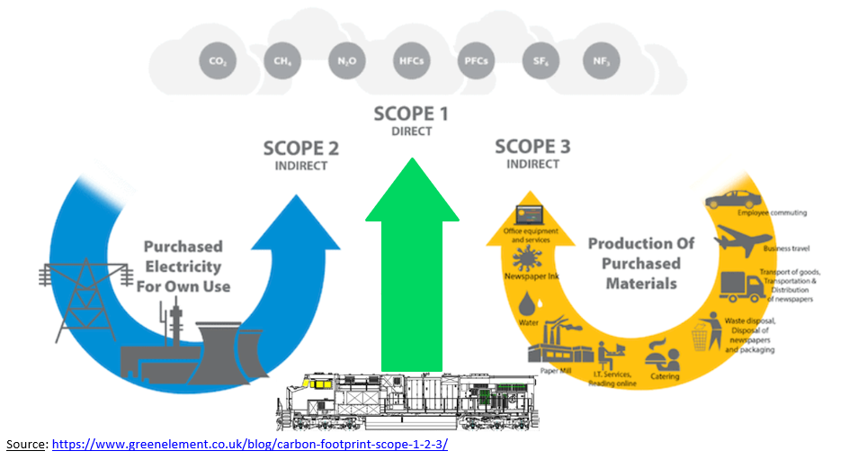Figure 1 – Emissions Scope Definitions

Table 1 is directly from the SBTi website and shows all Class 1 goals which have been approved (save BNSF which should have their goal approved in 2022). The goal dates vary but are mostly centered around the 2030 time frame. They have all chosen a “well below 2 degrees Celsius” goal for limiting long term global warming. You can further observe that the CN has committed to a Net-Zero goal by 2050, and UP has announced their intent to do so soon.
Under the Targets column in Table 1 the goals are stated as a percentage improvement from a base year, also whether the goal is Absolute, or Intensity based. Both BNSF and UP railroads have chosen the less common Absolute goal measure, where future growth and volume increases will make their GHG reduction goals more challenging to achieve.

Class I Railroads and Description of GHG Emissions Reduction Goals
Further details for each railroad SBTi commitments include:
BNSF - Reduce absolute scope 1 and 2 GHG emissions by 30% by 2030 from a 2019 base year.
CN - Reduce scope 1 and 2 GHG emissions 43% per million Gross Ton Mile and scope 3 GHG emissions from fuel and energy related activities 40% per million Gross Ton Mile by 2030 from a 2019 base year – the target boundary includes biogenic emissions and removals from bioenergy feedstocks.
CP - Reduce Scope 1, 2 and 3 locomotive well-to-wheel GHG emissions 38.3% per Revenue Ton Mile by 2030 from a 2019 base year.
CSX - Reduce scope 1 and 2 GHG emissions intensity 37% per million Gross Ton Mile by 2029 from a 2019 base year.
NS - Reduce scope 1 and 2 GHG emissions 42% per million Gross Ton Mile by 2034 from a 2019 base year – the target boundary includes biogenic emissions and removals from bioenergy feedstocks.
UP - Reduce absolute scope 1 and 2 GHG emissions on a well-to-wheel basis from locomotive operations 26% by 2030 from a 2018 base year – the target boundary includes biogenic emissions and removals from bioenergy feedstocks.
KCS – Reduce scope 1 and 2 emissions 42% per million Gross Ton Mile by 2034 from a 2019 base year.
All railroads will need to submit more aggressive goals no later than 2025 to meet SBTi’s preferred ambition moving from the current “well below 2 degrees Celsius” to a new “1.5 degree Celsius”. The new strategy is being rolled out in response to increasing urgency for climate action and the success of science-based targets to-date.¹
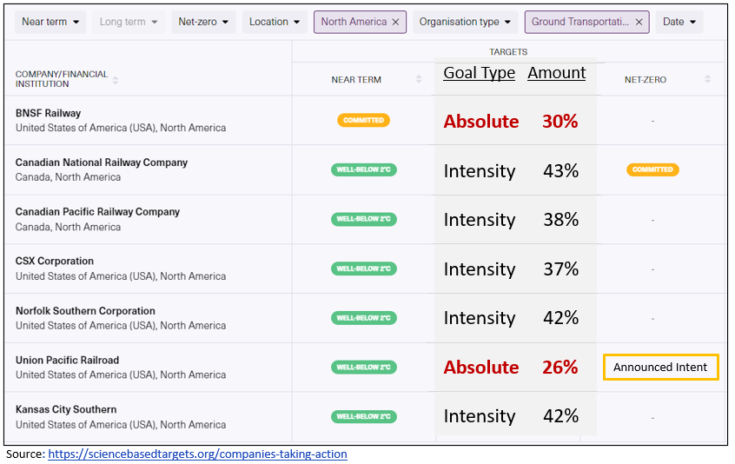Table 1 – SBTi Goals by Railroad

Figure 2 shows each Class 1 railroad and their base year and target year with associated percentage reduction. Note there are three different emissions measures being shown on this chart and the Variable Legend shows each emissions measure. Note mixed units on the Y-axis, so a ranking is not significant, rather the slope of the line and how each railroad has started in the early years.
Also note the “estimated” measures where applicable for 2020 and 2021 which have been calculated based on known annual diesel fuel consumption and prior year stated emissions measures from each railroad and using CO2e conversion factors that do not include any significant use of Biodiesel and/or Renewable diesel.
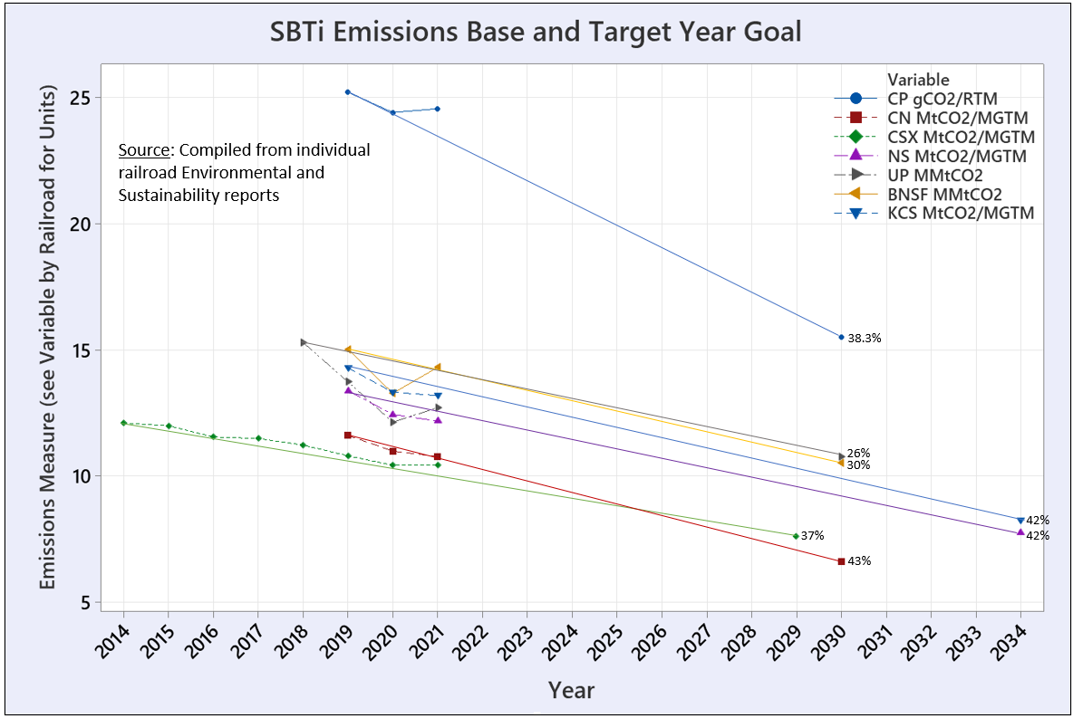Figure 2 – SBTi Emissions Baseline and Target Year for each Railroad with Associated Reduction Goal

Various Fuel Saving Approaches by Railroad
Table 2 highlights each railroad and their specific key initiatives that they have listed in their most recent ESG or Climate Action Plan reports from 2020 and 2021. It indicates the percentage of GHG coming from their locomotive fleets which are all very high in the 95% or higher range, with the exception of CN lower at 85% due to their ownership of both trucking and maritime fleets.
Some common approaches being used to reduce GHG emissions are Energy Management Systems (EMS) and lower Horsepower-Per-Trailing-Ton (HPTT) due to longer trains compliments of Precision Scheduled Railroading or PSR initiatives. Auto Engine Stop Start (AESS) and the use of Distributed Power (DP) technology is also listed as being in common practice. Less common approaches are the use of biofuels (biodiesel and/or renewable diesel) with UP having announced a goal of 10% biofuel use by 2025 and 20% by 2030. The use of data analytics, having a fuel dispatching desk as part of their network train dispatching process, track lubrication and mother-slug units are also considered less common fuel saving practices.
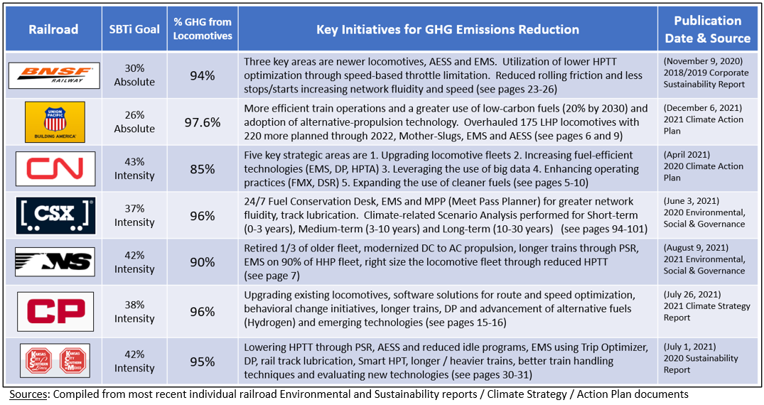Table 2 – Various Fuel Saving Approaches by Railroad

Historical Fuel Savings Industry Performance
The rail industry commonly uses a fuel efficiency measure of Gallons per Thousand Gross-ton-Miles which has been tracked for many decades. Figure 3 shows each of the seven Class 1 railroads going back to 2001 with KCS only disclosing their fuel efficiency metric starting in 2011. Notice the Canadian railroads have generally been the best performers and starting in 2013 both distanced themselves from their US peers. Most railroads stay in their own fuel efficiency “lane” except for CSX that now looks more like a Canadian railroad in terms of exceptional fuel efficiency. Still, there remains a 30% gap between the best and most challenged railroads looking at the most recent year of 2021.
Figure 4 shows the combination of all Gallons and all Gross-Ton-Miles, so it is an industry performance metric for the Class 1’s that indicate a roughly 1% improvement per year the past decade. There are some slight anomalies such as 2018 underperforming and 2020 overperforming but notice that the most recent year of 2021 shows the same roughly 1% improvement. If we look at the aggregate SBTi goals out to 2030 and the glide slope required for the industry to achieve that goal, it will require from 2021 forward, a 2.5% year over year improvement in fuel efficiency to meet the SBTi targets. Whereas on the current historical glide slope, that would create an 21% percent gap between where railroads need to be and where they likely will be on their current trajectory or historical glide slope. Per the more challenging SBTi goals to be announced by 2025 mentioned earlier, this will likely mean the slope of the line shown in Figure 4 will be even steeper.

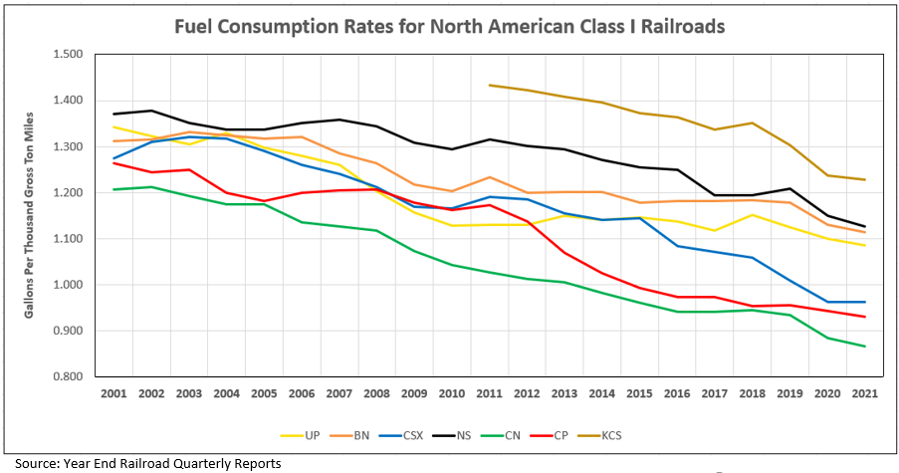 Figure 3 – Fuel Efficiency for Class 1 Railroads
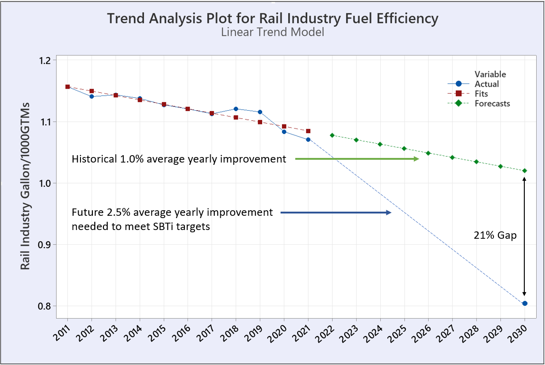 Figure 4 – Historical Glide Slope versus SBTi 2030 Goal

Marginal Abatement Cost for GHG Emissions Reduction
Figure 5 shows for illustrative purposes, a sample of many individual fuel saving initiatives grouped into nine categories. The y-axis measures the abatement cost in US dollars per Metric Ton of CO₂ equivalent. For most initiatives that are below the x-axis, they deliver a positive ROI meaning the value of the fuel savings is more than enough to offset the cost and maintenance of the technology. The bar height for each project specifies the strength of the fuel savings or magnitude of the ROI. The x-axis measures the emissions intensity in Metric Tons of CO₂ equivalent per Million Gross Ton Mile, so the wider each bar, the more it moves the needle in reducing GHG emissions intensity. You’ll notice some initiatives are above the x-axis meaning they will present a net cost to pursue, both biofuel initiatives and advanced technology projects fit into those categories.
The SCC or Social Cost of Carbon is also drawn in at the current $50 per Metric Ton and that value will likely increase in the future. The SCC is used to estimate in dollars all economic damage that would result from emitting one ton of carbon dioxide into the atmosphere. It indicates how much it is worth to us today to avoid the damage that is projected for the future.²
The social cost of carbon is used to help policy makers determine whether the costs and benefits of a proposed policy to curb climate change are justified. A higher SCC generally means that the benefits of a particular climate policy to cut CO2 justify its cost; a low SCC makes a policy seemingly cost more than the benefits it ultimately delivers. Theoretically, the SCC should increase over time because physical and economic systems will become more stressed as the impacts of climate change accumulate.²
A generic 2030 goal is shown on the chart and the takeaway is that railroads will not be able to pick and choose which projects to pursue. They will likely need to pursue all of them to achieve their 2030 emissions goals.
Figure 5 also shows that biodiesel and renewable diesel are projected to be expensive yet effective options for achieving the SBTi goals. They constitute the “easy button” – but should be used as a last resort.
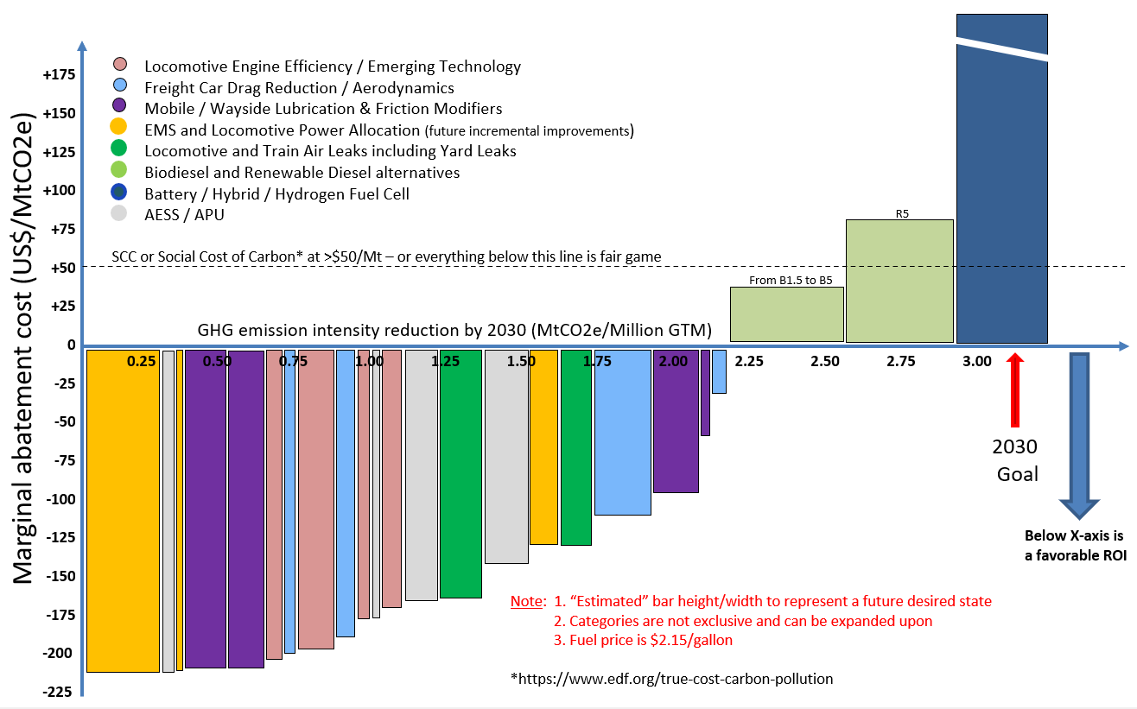Figure 5 – Sample Marginal Abatement Cost Chart

Case Study 1 – Replacement of EUI Fuel Injectors
Locomotive aftermarket parts sales is a very large business within the rail industry and fuel injectors are one particular piece that can play an outsized role in fuel conservation. A large Class 1 railroad was experiencing strong headwinds in their fuel conservation efforts and upon some investigation, it was learned that the sourcing department had decided a few years earlier to change to a lower cost fuel injector vendor without considering that there could be a difference in actual fuel consumption or emissions performance. It was discovered that there was a 3% difference in Brake Specific Fuel Consumption or BSFC as shown in Figure 6, between the two suppliers of fuel injectors.
At the same time, SwRI observed differences in NOx and fuel efficiency in locomotives of the same model and EPA Tier as part of the annual AAR-coordinated and EPA required “End of Useful Life” emissions testing.

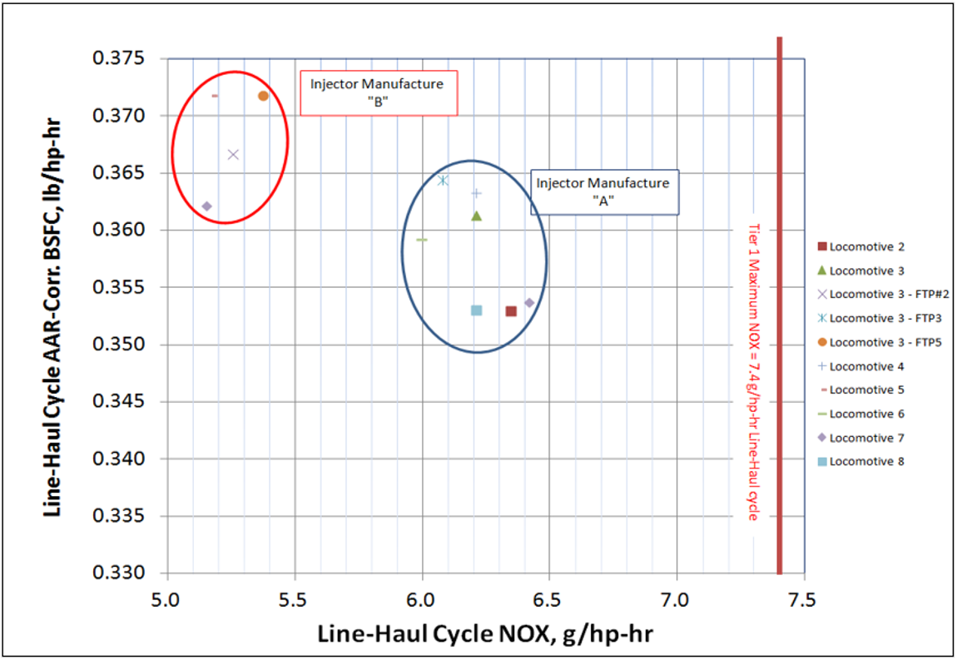
Figure 6 – BSFC Performance for Injector Brand A versus Brand B

Figure 7 shows benefits in HC, CO and PM emissions which all decreased with “A” injector, only NOx saw an increase, which was still well below the EPA required limit.
The lesson learned here is to ensure performance and fuel economy of emissions critical engine parts are comparable before changing suppliers – particularly those which have a strong determination on fuel consumption such as fuel injectors.
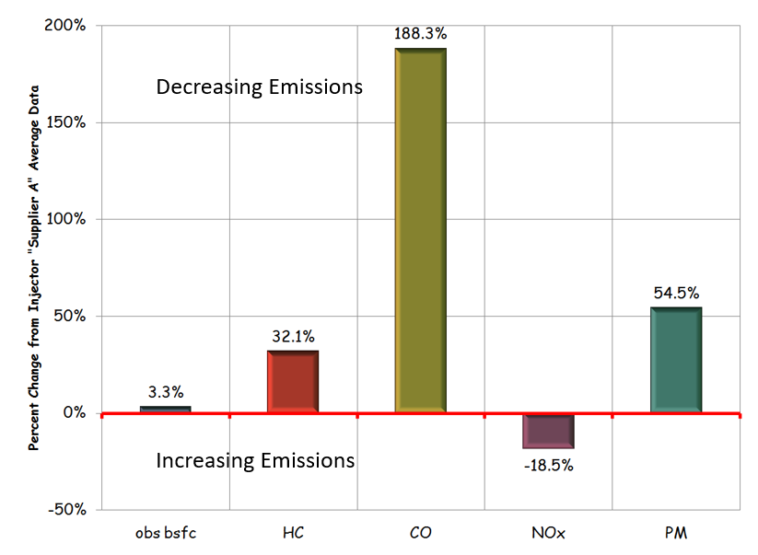
Figure 7 – Emissions Difference for Injector Brand A versus Brand B

Case Study 2 – EUI Timing Optimization
While testing the various fuel injector vendors looking for the extent of the fuel consumption penalty described in Case Study 1, it was noticed that the NOx levels were quite low in comparison to the applicable EPA NOx limit of 7.4 g/hp-hr. In other words, the NOx compliance margin was very large, with an associated fuel efficiency penalty. Upon further investigation and working with the locomotive OEM, a modified and optimized EUI timing map was developed and added to the EPA certificate of conformity, which provided a smaller NOx compliance margin, but with a resulting 2.8% fuel efficiency gain. The new timing map was pushed through a software upgrade to the locomotive fleet.
Figures 8 shows the relationship between the BSFC and the Line-Haul duty cycle NOx emissions output.

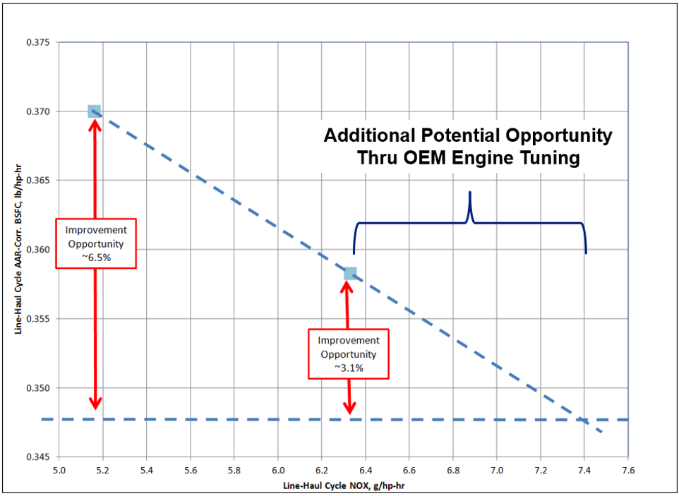
Figure 8 – BSFC versus NOx Relationship

Figure 9 shows both the BSFC for the railroad specific duty cycle in relation to the EPA Line-Haul NOx, with a potential fuel savings curve overlayed up to the NOx limit of 7.4 g/hp-hr. The better control over NOx emissions, the less NOx compliance is needed, and fuel efficiency can be optimized.

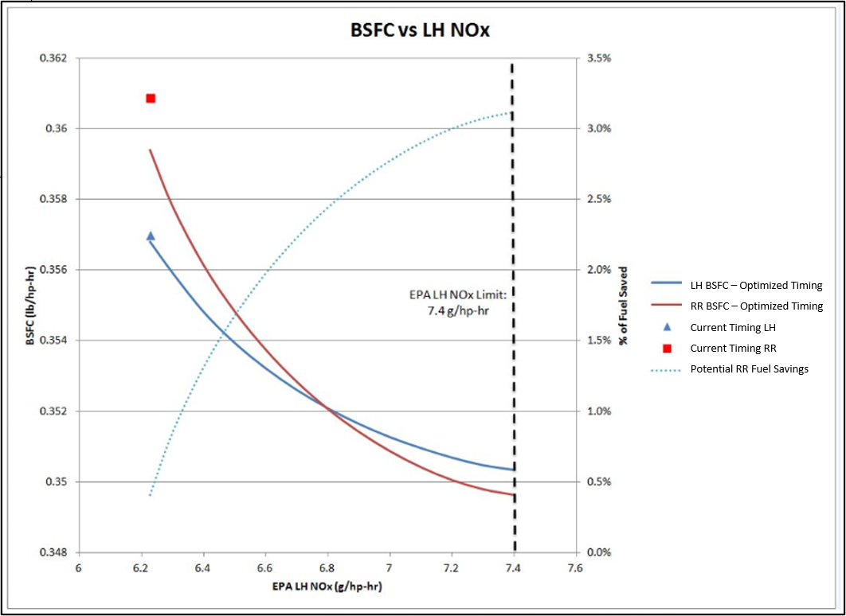
Figure 9 – Optimized Timing Map Fuel Savings Curve versus Chosen NOx Limit

Case Study 3 – Locomotive and Train Line Air Leaks
Air leaks in train service are common and the locomotive compressor must make up for the resulting air loss. The air compressors in most locomotives are either shaft-driven or motor-driven, but both put extra load on the engine. The fuel penalty associated with the extra load due to running the air compressor to recover the loss of air pressure is significant, and methods need to be developed to easily identify, repair, and minimize the larger leaks both within the locomotive and the associated cars within the train line.
Figure 10 shows a reference from a 2020 LMOA paper³. The test measured the NTSFC difference both with and without a 30 SCFM induced air leak, which indicates an average NTSFC fuel penalty of 4.0% over the switcher duty cycle, 1.9% over the line haul cycle, and 1.8% over the AAR medium duty cycle.
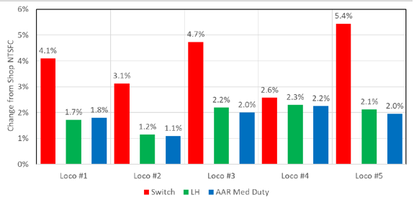
Figure 10 – Locomotive Fuel Penalty with a 30 SCFM Air Leak

A reliable and efficient method to locate and identify locomotive and train line air leaks is essential to addressing this source of fuel inefficiency. The effectiveness of the on-board AESS system is severely compromised due to locomotive air leaks, thus providing another source of needless and excessive fuel burn for no effective work performed.
SwRI is working on a TRB funded project to develop and demonstrate an autonomous system to identify compressed air leaks on locomotives and rail cars using acoustic imaging⁴.
The Fluke ii900 industrial acoustic imager shown in Figure 11 provides an effective tool to identify air leaks a sample of which output is shown in Figure 12. Future optimization of the sensor into existing wayside inspection portals, along with the appropriate AI integration will provide an automated detection system for future use, to significantly decrease the number and size of air leaks on locomotives and car freight.
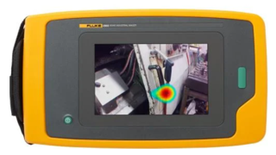
Figure 11 – Fluke ii900 Industrial Acoustic Imager

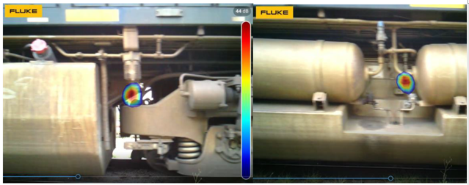
Figure 12 – Sample output of air leak identification using the Fluke ii900 device

Case Study 4 – Locomotive NTSFC Benchmarking by Locomotive Model
Fuel consumption guarantee testing is performed periodically by some of the Class I railroads prior to and during delivery of new locomotive model fleets. While this data is proprietary to the customer and specific OEM, an overview of anonymous data points shown in Figure 13 clearly shows a large amount of variation in measured AAR-corrected NTSFC, a full 17% swing between the most and least fuel efficient within a similar Tier standard.
As an industry, railroads would benefit from pooling this valuable, credible, and independent fuel consumption data to help with decision making in terms of which units to store and which to deploy based on fuel efficiency measures.
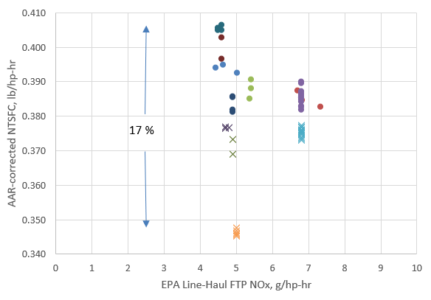
Figure 13 – AAR-corrected NTSFC Performance Across Multiple Locomotive Models

Case Study 5 – Aerodynamic Improvements
The shape of rail cars and locomotives within the North American freight industry have not changed in many decades and it is evident that no consideration was made for aerodynamic efficiencies in the current and past designs being offered from the major OEMS for cars and locomotives.
Union Pacific railroad has historically performed a considerable amount of research on aerodynamic improvements to both locomotives and freight rolling stock. Many test methods have been used including wind tunnel testing, Computational Fluid Dynamics (CFD) research, and full scale testing, both at TTCI in Pueblo, Colorado and in revenue freight service.
Figure 14 shows the curve of aerodynamic and other forces and the resistance or power required for each, to move trains at various speeds. Given all railroads are focused on increasing network speed and providing stellar service to their customer base, rail aerodynamics must play a future role in helping conserve fuel as network velocity increases.
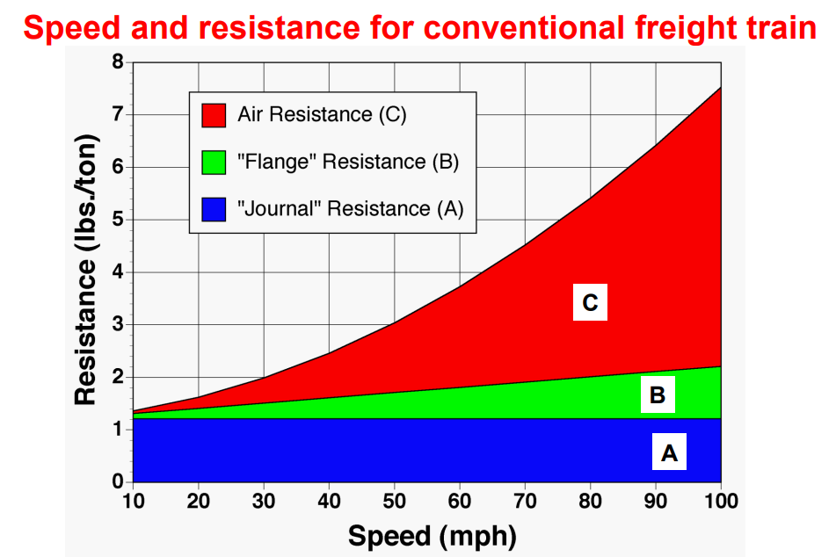Figure 14 – Resistance Forces for Freight Trains at Various Speeds⁵

An example of simple modifications made to a new build of covered hoppers is shown in Figure 15 where both the cavities around the bottom hopper chute and top walkway supports have been enclosed providing a more aerodynamic running surface, removing sharp angles and open voids which create air turbulence and resulting excessive drag.
These modifications or aerodynamic treatments were simple to design / install being lightweight and did not interfere with any visual inspection requirements.

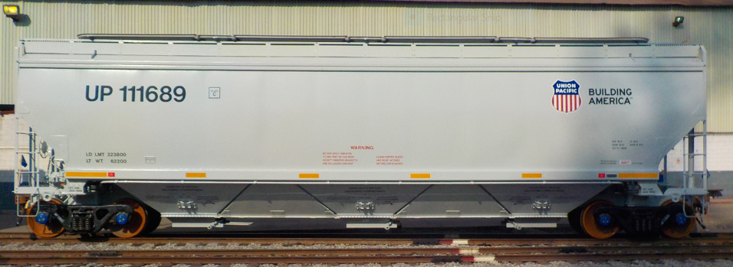Figure 15 – Covered Hopper with Aerodynamic Modifications Installed

Through CFD analysis, with a representative 6 degree wind yaw, Figure 16 shows a 22.9% reduction in aerodynamic drag on the 3rd car which is considered representative of the remaining cars in a unit car train. A drag development chart is shown with clear separation between the baseline and modified train car consist with a drag count reduction of 33 from a baseline of 144 cts (a dimensionless unit drag count measure) due to the addition of the simple and inexpensive aerodynamic treatments.

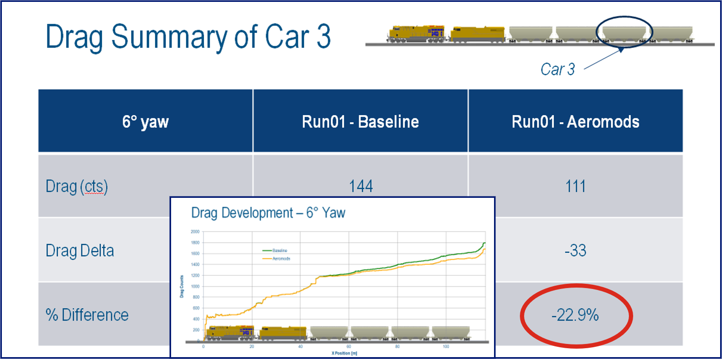Figure 16 – Drag Summary of Car 3 at 6 degree yaw

Surface pressure plots shown in Figure 17 indicate far less air impingement due to closing off the gaps between the dump gates. All these seemingly small details can add up to a big improvement in fuel efficiency.
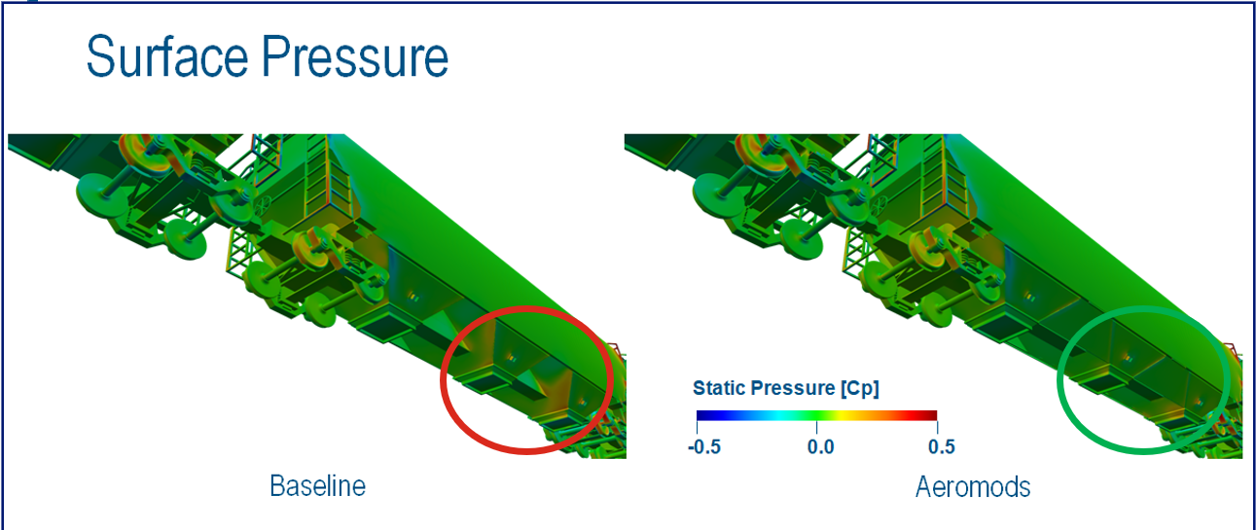Figure 17 – Surface pressure plot showing underbody impingement with and without aerodynamic treatment

The wind tunnel used for testing shown in Figure 18. Revenue field testing and Train Performance Simulator modeling all showed similar fuel savings from reduced drag. The range of savings from all four testing procedures ranged from a low of 6% to a high of 7.5% with close agreement between the various tests performed. This indicated a high degree of certainty that the simple aero treatments were successful in reducing drag and providing fuel savings in revenue service.

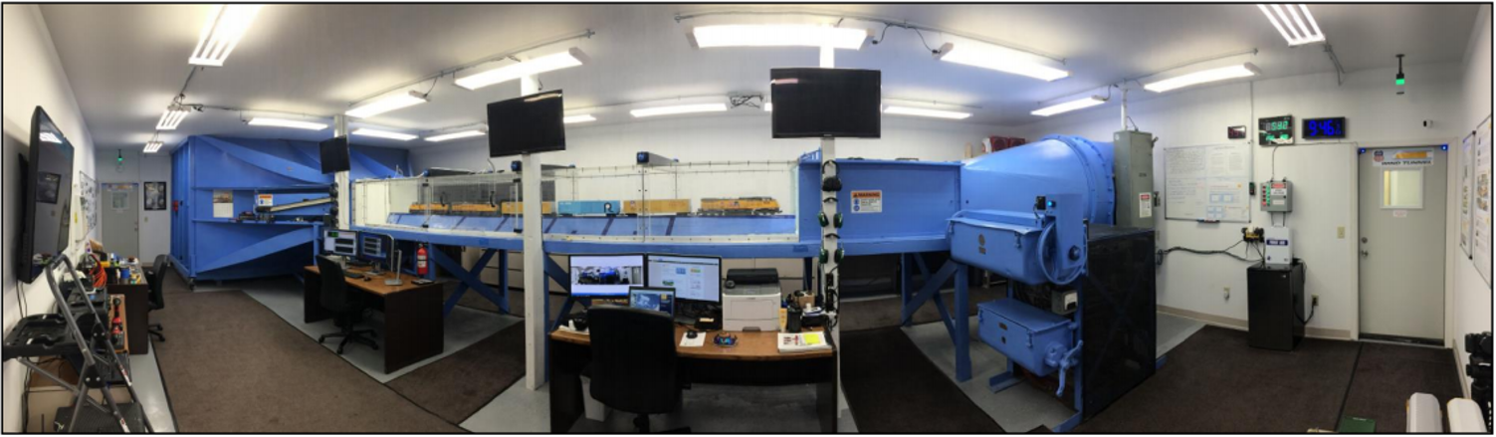Figure 18 – Wind Tunnel configured for G scale (1/29th) model testing (now owned by MxV Rail in Pueblo CO)

Similar aerodynamic treatments are available for most major freight car types and involve smoothing roof lines, applying side skirts and underbody treatments to smooth transition and trip points all with the intent of reducing drag and improving fuel conservation. These simple aerodynamic modifications can either be designed and included for new builds or installed in kit form for existing car fleets already in service that are going through periodic maintenance cycles.
This type of technology is agnostic to the fuel type being used to pull freight, so will be just as useful in the future for Battery Electric or Hydrogen Fuel cell powered locomotives pulling revenue freight trains.
There are challenges though, as railroads only own a portion of the cars that they haul. Who pays for the modifications versus who sees the fuel savings, would all have to be worked through. At the very least, new builds with aerodynamic modifications, should be the first tranche of aerodynamic cars introduced. Recently purchased fleets should then be the next priority with in-field modification kits made available. Customer owned fleets would also be a key opportunity as would leased fleets from TTX and other car owners.
Funding for continued research on aerodynamic opportunities will be key. Government funding through TTC or MxV Rail to perform not only wind tunnel testing, but also full scale energy tests will be a requirement. CFD analysis will also be required and Dassault Systemes has performed this type of analysis for the rail industry in the past. OEM assistance and support for both locomotives and rail cars will likely help drive needed improvement. A multi-year plan and the leadership to drive things forward with industry support to share the best practices and accelerate the pace of improvement will be necessary.

Biodiesel and Renewable Diesel Fuels
Biofuels usage is increasing as a method to reduce the carbon intensity of fuels to help meet the aggressive GHG reduction goals. However, there are challenges. Biodiesel, while available, has operability issues in cold weather which affect virtually all Class I railroads on portions of their network. Renewable diesel, has no such operability issues, though availability may be problematic given all transportation and other major industries which rely heavily on diesel fuel are looking to increase renewable diesel usage with a limited production volume increase forecast into the future.
Feedstocks for Renewable diesel are currently limited to the major sources of soybean and canola oil, animal fats, and used cooking oil, which are both somewhat finite in volume and only increase in direct correlation with population growth. Expansion for US Renewable diesel is limited not only by feedstock availability, but also by lack of support from existing Renewable fuel policies, per a new report from the clean fuel consultancy Cerulogy prepared for the International Council on Clean Transportation (ICCT)⁶
The price of biodiesel and renewable diesel may well become unattractive for railroads as many different industries both within and outside the transportation industry compete for a limited supply.
Table 3 shows the limited amount of publicly available locomotive biodiesel and renewable diesel test studies performed to-date. More research is required in this space to fully understand the operability of Biodiesel and the effect of lower energy content which affects both types of diesel biofuels.
Progress Rail has announced the approval of B20⁷, while Wabtec is approved to B5.

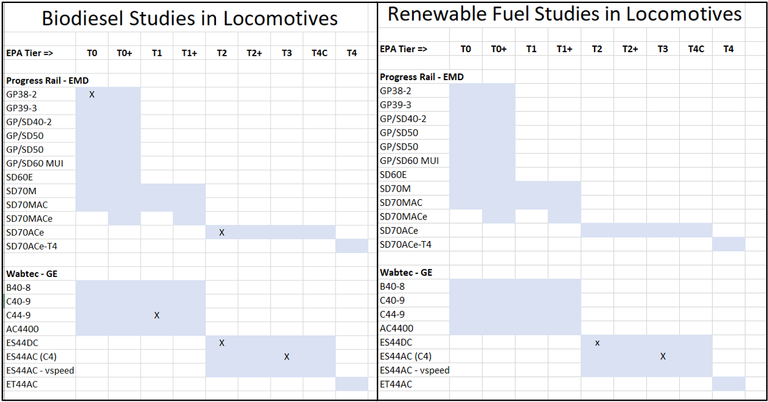Table 3 – Locomotive Studies Performed with Biodiesel and Renewable Diesel Fuels

Figure 19 shows a bubble plot of the volume-weighted average carbon intensity from CARB certified fuel test samples for both Biodiesel and Renewable diesel. Note the very broad distribution for both types of biofuels. Not all biofuels are the same in terms of their carbon intensity – being able to choose fuels that are towards the lower end of the scale would help lower associated carbon emissions considerably.
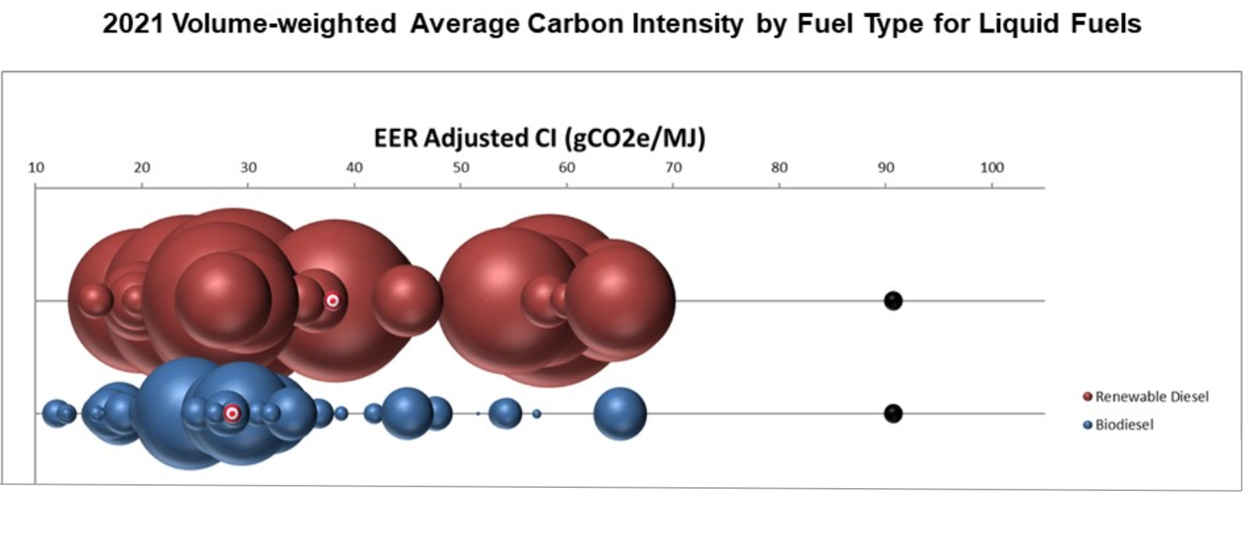Figure 19 – Bubble Plot of Energy Based Carbon Intensity of both Biodiesel and Renewable Diesel Fuels⁸

Getting to Actual Fuel Savings
Many technologies, regardless of their platform, advertise fuel savings that have been quantified through controlled testing, devoid of the typical operational variation that is freight railroading. Operational field testing, is by far the most realistic avenue to determine actual fuel savings and many factors will then need to be applied before an “actual” and “bankable” fuel savings amount can be quantified. Without an adequate “actual” fuel savings percentage, determining ROI (Return on Investment) becomes problematic and unrealistic.
Figure 20 shows five different technology platforms, including operational change and training programs all with the intent of saving fuel and reducing GHG emissions intensity. To the right of each different technology platform are different “hoops” that need to be progressively jumped through to arrive at a final realistic fuel savings. In the statistical world, this is often referred to as a “Rolled Throughput Yield” where the probability of success (percent fuel savings in this example) is dependent on passing through successive filters, or criteria to end up with a final end process, or actual fuel savings. This figure will often differ significantly from what is advertised by a vendor where testing has been performed in near laboratory conditions with little field variation being introduced.

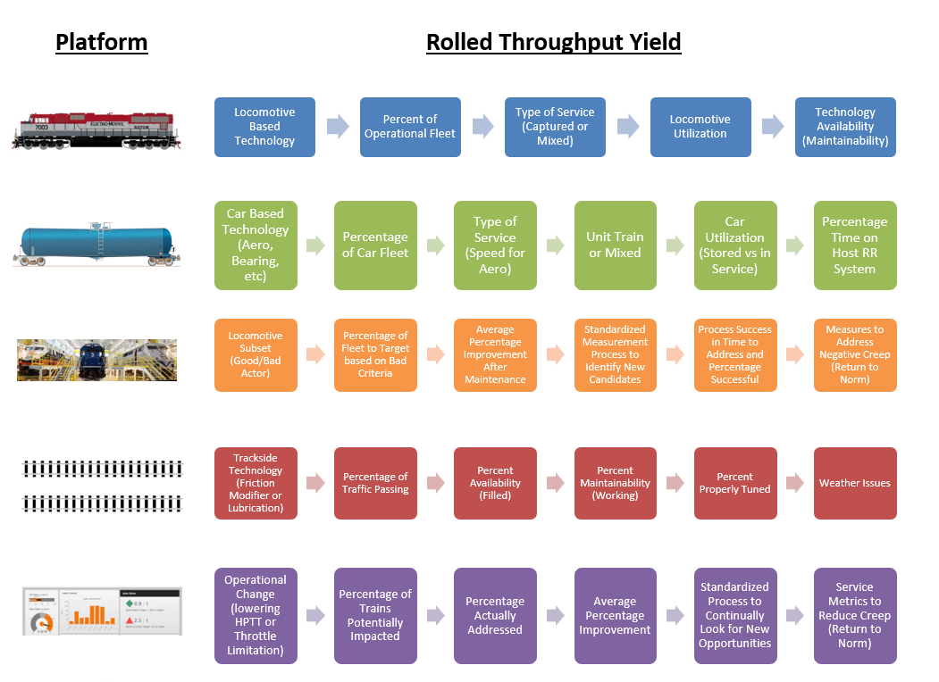Figure 20 – Rolled Throughput Yield for Various Fuel Saving Technology Platforms

Future Technology Progression
Figure 21 shows a pictorial timeline for various alternate locomotive fuel technologies such as natural gas (NG), battery electric (BEL) and hydrogen fuel cells (HFC). Virtually all Class I railroads have dabbled in natural gas technology, even sharing tender cars for various field tests over the last three decades. Hydrogen fuel cell powered locomotives have been attempted by BNSF and more recently championed by CP. Battery electric locomotives have a long history as switcher power, and both OEM vendors have various offerings for both yard and line-haul locomotives. UP made the largest splash by announcing the purchase of 20 yard switcher locomotives to be delivered in 2023 at two of their major yard facilities.
While the technology development for both BEL and HFC appear to have the upper hand at present, the power density of BEL is nowhere near what would be needed for a line-haul locomotive and the infrastructure for both technologies is still in the early stages of development with the AAR. As presented earlier, it’s a certainty that both BEL and HFC driven fuel technologies will not be moving the needle significantly to achieve the aggressive SBTi goals out to 2029/2034.
As to the long term net zero 2050 emissions goal that CN has committed to thus far, and UP announced the intent to do so in the future, these technologies may indeed end up being the sole available paths to achieve those long term goals. This assumes the technology can be advanced and improved quickly and that it is likewise adopted quickly. For perspective, the transition from steam power to the current diesel-electric took more than four decades.
In the interim, many technologies and operational approaches exist to significantly reduce GHG emissions using the current diesel-electric installed fleet. This is likely sufficient to reach the near term goals, but it will require an “all hands on deck” and “what projects to pursue? – all of them” type mentality.

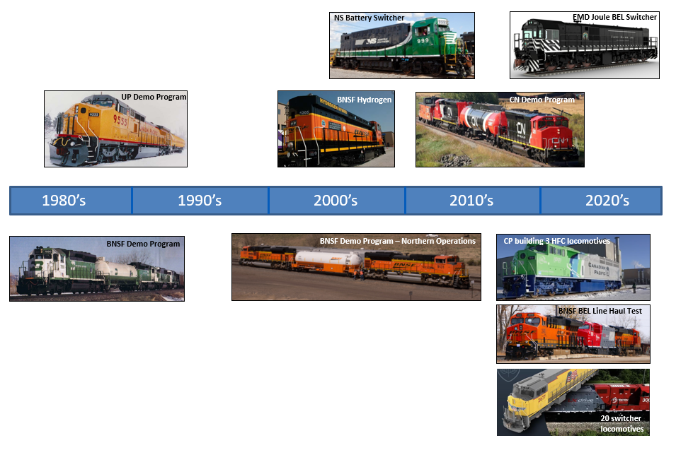Figure 21 - Technology Progression Pictorial from the 1980’s thru to the Present Decade

Trucks versus Rail – Possible Threat?
The oft mentioned quote that “rail is three to four times more fuel efficient than truck” could be in jeopardy in the future depending upon how quickly the rail industry accelerates their fuel efficiency improvement glide slope and what new technologies the trucking industry adopts. This may include electric or fuel cell vehicles with autonomous capability.
The obvious advantage that the trucking industry has over rail is their relatively quick comparative speed in introducing new technology due to turning over assets - every 2 to 4 years, on average for tractors and every 8 years on average for trailers. Compare this to the rail industry where locomotives and freight cars can be in service for almost 50 years thus making new technology adoption very slow.
An excellent organization for the trucking industry is NACFE, the North American Council for Freight Efficiency which was formed in 2009. Their mission is to “drive the development and adoption of (fuel) efficiency enhancing, environmentally beneficial, and cost-effective technologies, service and methodologies in the North American freight industry.⁹
Figure 22 shows a NACFE illustration¹⁰ showcasing the 85 different technologies grouped into fifteen separate categories, all currently available for adoption into existing and new fleet purchases.

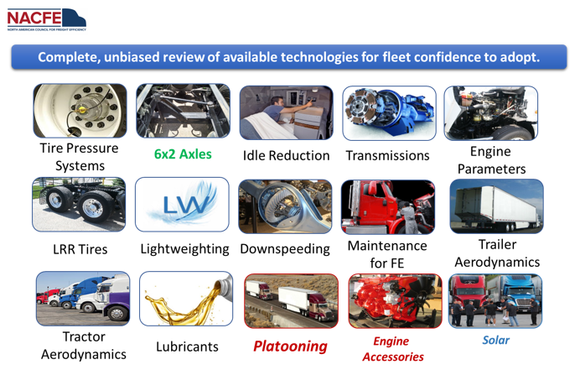Figure 22 – Technology Groupings for Tractor / Trailer Fuel Efficiency Technologies

With so many different technologies to choose from, what type of mechanism exists to help with deciding which ones to adopt quickly and which ones to allow to mature for future adoption, or simply to leave alone? NACFE also provides confidence ratings and payback information per the graphic in Figure 23 which helps with the decision making process.

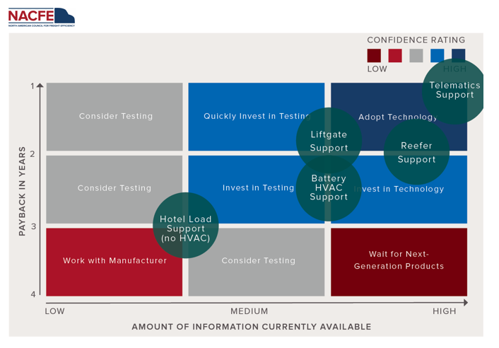Figure 23 – Technology Adoption Grid Showing Confidence Ratings, Payback and Available Information Metrics

So, with all this plethora of information available from NACFE, do fleets that use this information actually perform better than fleets that do not? Figure 24 shows the difference, and it is significant. Further, the Department of Energy (DoE) has provided significant funding in the form of SuperTruck I, II and currently III to both assist in the development and research of future technologies, and the implementation of cutting edge technologies including battery electric vehicles.
Given technologies have been identified through DoE funding to almost double the existing fuel efficiency of the trucking industry and the fact that a sampling of SBTi and other GHG emissions goal reduction appear to be more aggressive than the goals that railroads have announced (39% to 55% for trucking versus 26% to 43% for rail within comparable time frames) – there could be a future threat from the trucking industry that would shrink that “three to four” fuel efficiency advantage for rail, more towards truck, which already has the built-in advantage of first / last mile convenience and improved service metrics with consistency and reliability enhancements over rail.
When will the rail industry develop an organization comparable to what NACFE provides for the trucking industry? Looking at the various Class I railroads and what initiatives they are working on to provide greater fuel efficiency, there does not appear to be a unified information sharing approach that can benefit the industry as a whole.
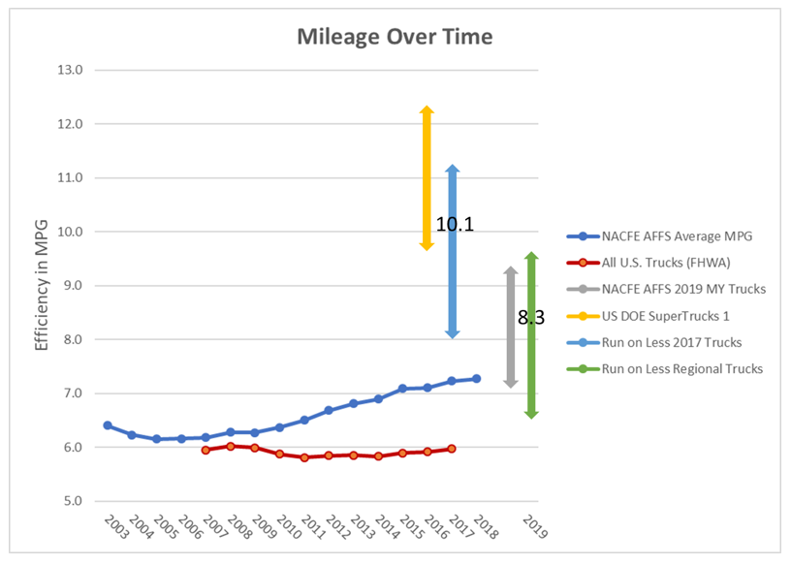Figure 24 – Fuel Efficiency Trends for Various Fleets and Future Possibilities from DoE SuperTruck Funding

Collaboration and Industry Leadership from the AAR
The AAR recently published an article “Freight Railroads & Climate Change”¹¹ which outlines various approaches to increasing fuel efficiency shown in Figure 25. Most of these initiatives have been in practice for many years and few are considered new technology. Aerodynamics is one bright spot of untapped capability though lacks the required plan and funding at present to move forward in a meaningful way to make this an industry strategic initiative.
The document highlights the need for “significant investments are essential to unlocking energy solutions capable of reducing GHG emissions” – hopefully the various committees already in place can take a NACFE approach to providing the needed leadership for the rail industry to attain their short term SBTi goals.
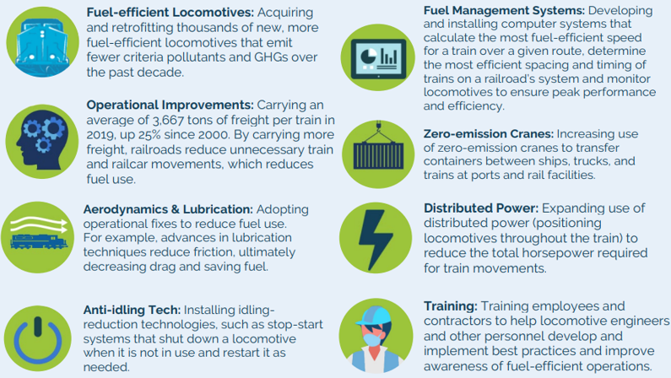Figure 25 – Various Technology, Training and Approach Initiatives for Rail Fuel Efficiency Improvement

Conclusion
The rail industry stands at a critical juncture in a post PSR world. The need for reliable, dependable and efficient customer service performance has never been greater, while new carbon-free locomotive technology to attain a 2050 long term net zero GHG emissions goal will be the largest motive power technology leap for the industry since moving from coal fired to diesel-electric locomotive power beginning in the 1930’s, often referred to as Dieselization.
Even the near term SBTi goals out to 2030 seem very difficult to achieve with the current level of technology investment and operating practices, given the historical performance of a 1% per year improvement in fuel efficiency pales in comparison to the required 2.5% a year improvement needed immediately and continuing every year for the next 8 years.
A primer for accelerating GHG emissions reduction is summarized in the following steps:
- Take an honest look at the inventory of fuel conservation initiatives planned, will they suffice for both short and long term SBTi goals? (the honest answer is likely - no)
- Refer to Figure 5 – when asking which projects do we need? The answer is “all of them”
- Industry and Government funding will be key
- Some technology approaches need an industry push / support, such as aerodynamics, comprehensive track lubrication, air leak detection, and AESS effectiveness
- Industry collaboration and leadership (NACFE like service) in conjunction with OEM support will be crucial for long term success
- Biofuels will likely be an expensive stopgap solution for attaining a portion of a railroad’s SBTi goals
A full-court-press and “all-in” approach, with full support from various critical railroad departments (Legal, Environmental, Operations, Finance, Purchasing, Fuel Management and the most important, Mechanical) will be able to yield not only the short term goals, but additional improvement as a net-zero goal is approached by 2050.
New approaches and new technologies outlined in this paper will be sufficient to meet SBTi goals if the railroads move quickly, but delay will quickly “eat up” the available runway to attain the aggressive goals outlined.
Leadership from the AAR and FRA, including targeted funding, and an industry mindset of “a rising tide lifts all boats” and best practices sharing will pave the way towards GHG emissions reduction success.

REFERENCES
- https://sciencebasedtargets.org/news/sbti-raises-the-bar-to-1-5-c
- https://news.climate.columbia.edu/2021/04/01/social-cost-of-carbon/
- Hedrick, J. “AAR RP-589 Locomotive Air Compressor Load,” LMOA – Proceedings of the 82nd Annual Meeting, pp. 186-200 (September 2020)
- Stoos, C. “Autonomous Detection of Compressed Air Leaks on Trains,” submitted for publication at the 2022 LMOA Annual Meeting (October 2022).
- https://web.engr.uky.edu/~jrose/RailwayIntro/Modules/Module%203%20Train%20Energy,%20Power%20and%20Traffic%20Control%20REES%202010.pdf
- https://dieselnet.com/news/2022/01cerulogy.php
- https://www.progressrail.com/en/Company/News/PressReleases/ProgressRailApprovesB20BiodieselFuelforUseinEMDEngines.html#:~:text=Progress%20Rail%20Approves%20B20%20Biodiesel%20Fuel%20for%20Use%20in%20EMD%C2%AE%20Engines,-August%2026%2C%202021&text=ALBERTVILLE%2C%20Ala.,operational%20efficiency%2C%20and%20reduce%20emissions.
- https://ww2.arb.ca.gov/resources/documents/lcfs-data-dashboard
- https://nacfe.org/our-story/#:~:text=NACFE%2C%20The%20North%20American%20Council,the%20North%20American%20freight%20industry.
- https://nacfe.org/wp-content/uploads/2020/01/NACFE-2019-Annual-Fleet-Fuel-Study-Report-122919-FINALA.pdf
- https://www.aar.org/wp-content/uploads/2021/02/AAR-Climate-Change-Report.pdf

